

Introduction

Solving Human Resources for Health Efficiency Challenges by Using the HRH Optimization Tool for Primary Health Care (HOT4PHC)

Providing client-centered primary health care (PHC) requires a strong, well-managed health workforce. In order to deliver effective healthcare—as well as to maintain essential primary care services during public health emergencies—it is important for health facilities, national Human Resources for Health (HRH), and implementing partners to use HRH data to determine how to best configure their health workforce and services. With funding from USAID, the Human Resources for Health in 2030 program (HRH2030) team created the HRH optimization tool for primary health care (HOT4PHC)[1] to increase health workforce efficiencies by identifying and addressing HRH bottlenecks at frontline health facilities. HOT4PHC supports comprehensive planning and management of a more adaptive and diverse health workforce for achieving universal health coverage.

HOT4PHC helps improve workforce efficiencies by (1) identifying HRH imbalances within and across health facilities, (2) promoting patient-centered services through task-sharing and expanding service delivery beyond facility walls; (3) strengthening community engagement and health systems support functions; (4) configuring the health workforce in response to a public health emergency such as the COVID-19 pandemic; and (5) scaling up HIV antiretroviral therapy (ART) and tuberculosis control services and integrating them into PHC. The results from HOT4PHC benefit stakeholders at all levels in the health sector. The tool helps national and regional HRH planners and managers budget for addressing HRH shortages, revise guidelines for community-based service delivery, budget realistically for systems support such as supervision, or adjust job descriptions to allow for greater task-sharing. HOT4PHC results support district health management teams in identifying gaps and balancing its health workforce geographically, strengthening task-sharing and community-based service delivery and community engagement, and budget for additional staff in decentralized settings. At health facility level, HOT4PHC shows clinic managers whether its healthcare workers (HCW) are sufficient and have the right skills set for coping with the patient volume, how its coverage for critical services compares to national benchmarks, and what would be its HRH requirements and costs for scaling up and differentiating service delivery.

The application of HOT4PHC is led by local teams involving key stakeholders at service provider and administrative levels. It is an iterative process that fosters learning by providing new insights into a country’s health workforce, its efficiency challenges and solutions. The tool was tested in the Dioila district of Mali in November 2020. The data collection was entirely conducted by a local team of HRH experts and healthcare providers in Mali. Its data are used to illustrate the HRH efficiency cases in this document. These cases and solutions are for learning purposes only and are not meant to reflect actual health systems performance or be applicable in Mali.

This guide is not a step-by-step manual for how to use the tool and is instead designed to provide examples and suggestions on how decision makers may leverage the HOT4PHC to identify solution to an inefficient employment of the health workforce. For specific steps and directions on how to interact with the tool there are guides available from the HRH2030 [website](https://hrh2030program.org/tool_hrh-planning-for-hiv/).[2]

## PHC Service and HRH Data from Dioila District

Dioila district is located east of the capital Bamako in the Koulikoro region and can be reached in two and a half hours by car. The district population is about 339,000 spread out across 179 villages. There are 23 community health centers (HC) and one larger reference health center; all except one community HC are included in the field test. These 23 community and reference HCs see an annual volume of almost 550,000 patient contacts spread over 34 clinical activities covering family planning, maternal, neonatal and child health, infectious diseases, and other clinical, laboratory and pharmacy services. Ninety two percent of clinical services are delivered in the HCs; the remaining eight percent are child vaccinations delivered in catchment area communities. In addition, HCWs carry out some community engagement, supervision, and drug supply activities; professional HCW have three weeks and community-based workers two days of training annually. All these clinical, community and support activities are included in estimating staff requirements. The terms ‘activities’ and ‘tasks’ are used interchangeably. Services are provided by a total of 194 health professionals and community health workers (CHW). All personnel data are presented as full-time equivalents (FTE). See Figure 1 for a breakdown by cadre. HOT4PHC was completed separately for each of the 23 health facilities. All their service and HRH data were then imported and aggregated in a separate HOT4PHC. The aggregate data can be viewed and changed on the tool tabs listed in Figure 2.

***1. Client Volume***

***3. Service Providers***

***4.a&b Task Assignment (TA-Facility & TA-Community)***

***5. Community & Support***

***DASHBOARD (comparison of HRH scenarios)***

Figure 2. Tool Tabs for Viewing/Editing Data (colors match the tool tabs)

|  |  |
| --- | --- |
| Health Workforce in Dioila District | FTE Available |
| Medical Doctor | **12.0** |
| Medical Specialist | **1.7** |
| Physician Assistant | **8.2** |
| Midwife | **17.0** |
| Professional Nurse | **14.3** |
| Auxiliary Nurse Midwife | **11.0** |
| Nursing Aide | **26.2** |
| Pharmacist / Ph. Assistant | **15.0** |
| Lab Technician | **4.6** |
| CHW | **51.0** |
| Community Midwife | **29.1** |
| Medical Assistant | **2.0** |
| Enrolled Nurse | **2.0** |
| **Total** | **194.0** |

Figure 1. Health workers by cadre

This document addresses the following HRH efficiency cases:

* Identifying HRH inefficiencies across all health facilities
* Improving HRH efficiency through task-sharing
* Improving HRH efficiency by differentiating service delivery
* Assessing the HRH impact of integrating HIV/ART into PHC
* Assessing the HRH impact of a public health emergency

Each HRH scenario is described in detailed below using data from Mali and Malawi (for HIV/ART), which are adapted to illustrate the impact of HRH optimization on the staff situation in a health facility and the health district. Using HOT4PHC, each scenario except the first can be applied to a single health facility or to aggregate data from multiple facilities. The latter is done throughout this document.

## 1. Identifying HRH Inefficiencies across All Health Facilities

*Case goal: Identify provider imbalances and assess how efficiently HCWs deliver PHC services*

After importing the facility-specific data from all 23 HCs into HOT4PHC, the first step is to identify the health facilities that have staff shortages or excesses and for which HCW cadres. Figure 3 shows which tool tabs will be used in this HRH efficiency scenario. Figure 4, copied from the **FTE Summary** tab, lists in pairs of columns how many FTEs are available for each type of HCW and what the excess or shortage is in all 23 HCs. A simple average can be found on the last row. Overall, HCWs in Dioila district seem to be underutilized given that 10 out of 13 cadres show an FTE excess, which is highest for CHWs with 45. FTE excesses and shortages are calculated based on the following data built into HOT4PHC, all customizable: (1) current patient volume and current levels of community engagement and systems support activities (tabs **1** and **5**); (2) initial task-assignments to each HCW cadre (tabs **4.a and b**); and (3) client contact times provided by HCWs in Mali (tab **D, Task Times**, preconfigured). FTE excesses or shortages should be as close to zero as possible for a well-balanced health workforce. When summarizing FTEs across all cadres, the last five columns in the bottom part of Figure 4 in the next page, Seribila HC shows the largest FTE excess with 13 HCW. Overall, 85 FTEs out of 195 in total would be needed in Dioila district to deliver the current volume of services; 110 HCWs seem underutilized, which puts staffing levels at 229 percent overall in the last column. The two columns before show how much the FTE excess or shortage estimates vary, because the time of contact between patient and provider varies with each patient visit and for each activity.

***FTE Summary***

***FTE Chart***

***PHC Effort***

***Community+***

Figure 3. Tool Tabs used in this HRH efficiency case

Although HCs in Dioila district seem to have ample staff for coping with the current patient volume, there are three professional HCW cadres with shortages. Only a few HCs have physicians or medical specialists, each with an overall shortage of about two. More importantly, there is a gap of over three physician assistants. However, this average shortage underestimates the true need for such senior nurses, because four HCs do not have any advanced degree nurse as highlighted in red. Another three HCs have one full-time and one HC has a part-time senior nurse, also highlighted in red, all insufficient to cover the assigned patient volume. This means that there are approximately eight HCs in Dioila district that need an additional senior nurse, not just three as suggested by the simple average. The presumption is that all HCs should have enough senior nurses to ensure quality health services. Therefore, to assess the overall HRH situation it is important to examine the entire table and not only the bottom-line total. The **FTE Chart** tab shows the average, minimum and maximum FTE requirements and excesses or shortages in graphic form by cadre and for all cadres combined.

The **PHC Effort** tab shows coverage levels for key services (experimental) as well as the FTE requirements for five PHC clinical service areas (special programs and HIV/ART are addressed in the last two scenarios) and four community engagement and systems support areas. Other clinical and child health services require almost half of all FTEs, specifically adult (20%) and sick child (13%) consultations (see **tabs** **2.** column T or **4.a** column AH). Overall, clinical activities require 80 percent of all FTEs and community engagement and support activities the remaining 20 percent. Training alone takes up 12 percent of HCWs time, while supervision efforts are low with less than one FTE annually across all HCs. The **Community+** tab brakes out the community engagement and systems support activities into greater detail.

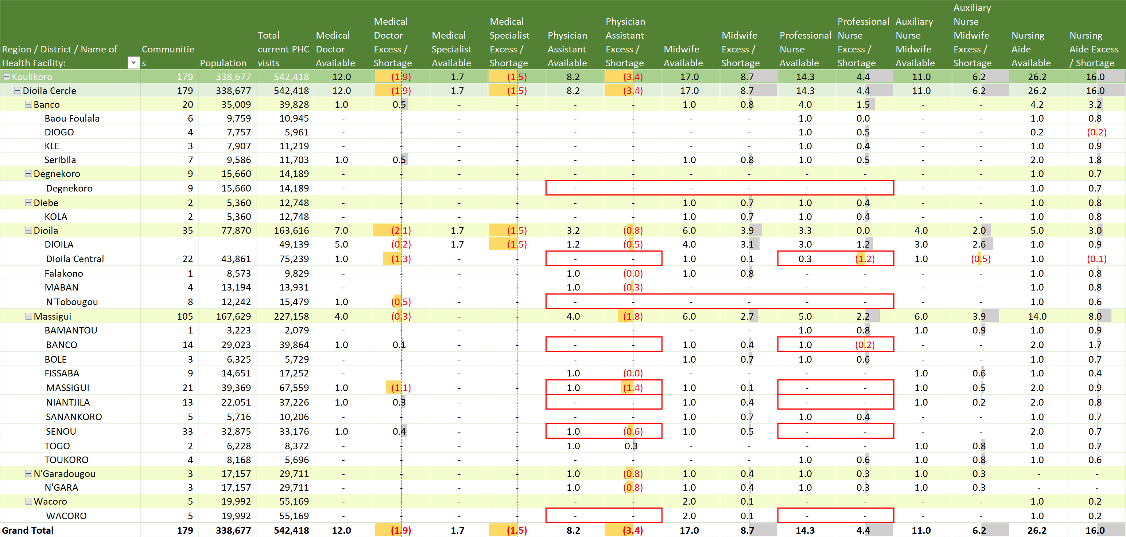

Figure 4. Summary of FTEs Available and Excess/ Shortage by Cadre for Regions and Districts, and Municipalities; based on Current Client-load (the bottom table is the continuation of the table above)

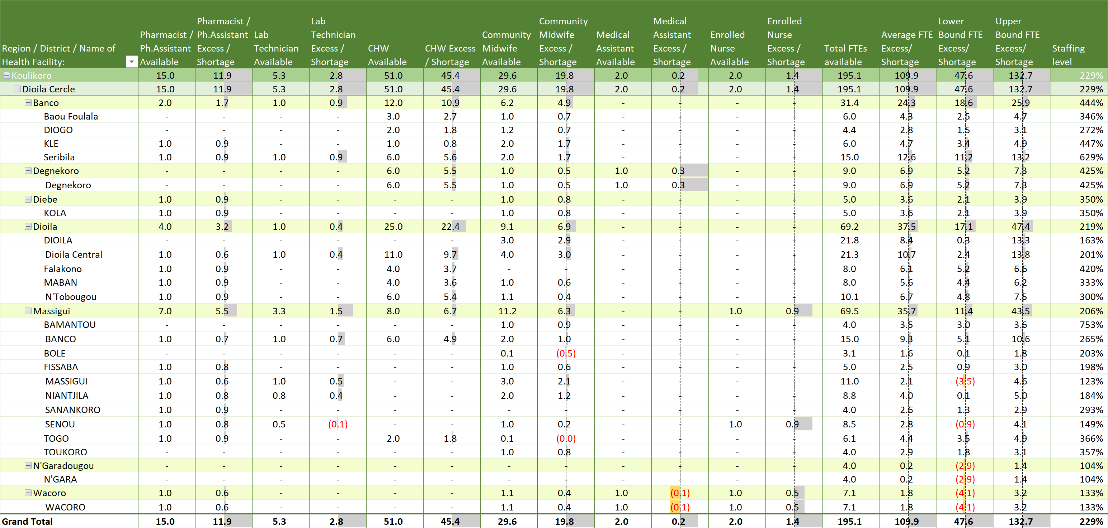

a. Interpreting the evidence and next steps

It is unlikely that over half of the HCWs in Dioila district are underutilized. HRH optimization using HOT4PHC is an iterative process that requires data validation and possibly adjustments to some of the data incorporated into the tool prior to roll out. Here are some of the next steps:

* **Validate client contact (task) times.** The Mali team provided two task time estimates for each activity. Longer times were assigned to the referral HC as well as physicians and physician assistants; community HCs and less qualified HCW were assigned shorter times. For several activities these times were very short and should be revisited and changed on tab **D. Task Times** and reassigned to specific cadres as needed on tab **C. Service Providers**.[3]
* **Validate service provider data.** Besides ensuring an accurate head count of staff actually providing services excluding any staff permanently absent, it is important to correctly estimate the time different cadres have for service provision. The assumption that unpaid CHWs and other lay worker are available 35 or more hours a week may need to be revisited.
* **Assess how efficiently HCWs are employed to deliver essential PHC services** compared to national service guidelines and standards and for achieving coverage targets.
* **Explore how increased task-sharing** can alleviate staff shortages in the next scenario.
* **Explore how service differentiation** by expanding community-based service delivery can alleviate staff shortages in the third scenario.

**If staff shortages persist despite task-sharing and service differentiation**, use FTE results (**FTE Summary** tab) and cost estimates (tab **7, Costs**) provided by HOT4PHC to advocate for the hiring (in a decentralized setting) or allocation (in a centralized setting) of additional HCWs.

## 2. Improving HRH Efficiency through Task-Sharing

*Case goal: Increase task-sharing to address an HCW shortage and increase service utilization*

Optimizing the health workforce through task-sharing is a four-step process when starting with data that are aggregated across multiple health facilities.[4]

***DASHBOARD (comparison of HRH scenarios)***

***4.a TA-Facility***

***FTE Summary / FTE Chart***

***2. PHC Delivery***

***6. Task-sharing***

***Start***

Figure 5. Tool Tabs used in this HRH efficiency case

1. Use aggregated data to identify HCW cadres for task-sharing opportunities
2. Identify HCs with these cadres where task-sharing can be applied
3. Use the individual HOT4PHC files for these HCs to implement task-sharing
4. Reimport all individual HOT4PHC files to reaggregate data across all HC

When working with aggregated data from multiple health facilities, summary data for patient volume, HCW numbers and task assignments are copied into the tool. This allows district health management teams to explore the HRH impact of task-sharing and service differentiation on all HCs in the districts on the **DASHBOARD** tab. The data from individual HCs can only be viewed on the **FTE Summary** and **FTE Chart** and the other purple tabs but not changed in the district-level HOT4PHC. Changes to patient volume, staffing, and task assignments for individual HCs can only be made in their respective HOT4PHC files, which then need to be reimported into a district-level HOT4PHC. Note that the district-level summary results from the bottom line of the FTE Summary are close to the results on the DASHBOARD, but they are not the same. This happens because the tool assumes on the **DASHBOARD** that all HCs have an equal number of patients, the same number of HCWs and identical task assignments when using summary data from multiple health facilities, which is not the case in reality. The bottom-line grand totals on the **FTE Summary** tab reflect the fact that each health facility is configured differently. Hence the differences between the numbers.

On the **DASHBOARD**, the user selects two scenarios that compare FTE results throughout HOT4PHC. The two scenarios are a combination of service modalities and task-sharing options applied to either the current patient volume or a potentially different volume. On most tabs current volume has green headers and potential volume has blue headers. The following user-scenario 1 should be selected.

Figure 6 shows the FTE results for the current client volume and as noted under the first HRH efficiency case, there is a gap of about eight physician assistants in the district. The chart also shows that auxiliary nurse midwives and enrolled nurses have additional time available and might be able to take on an additional patient volume. Column AH on tab **4.a TA-Facility** identifies which clinical tasks take up most of providers’ time; these tasks should be the priority for task-sharing as long as all cadres concerned are qualified to conduct these tasks as shown by the cell shading in a darker shaded light green (task is recommended), light green (with supervision only), light grey-blue (task is not recommended), or grey (task is not designated on tab, **E, Task Sharing Guidelines**). Sick child visits and general adult consultations are the most time-consuming tasks and can be shared between physician assistants, professional nurses, enrolled nurses, and auxiliary nurse midwives (sick children only for the latter)

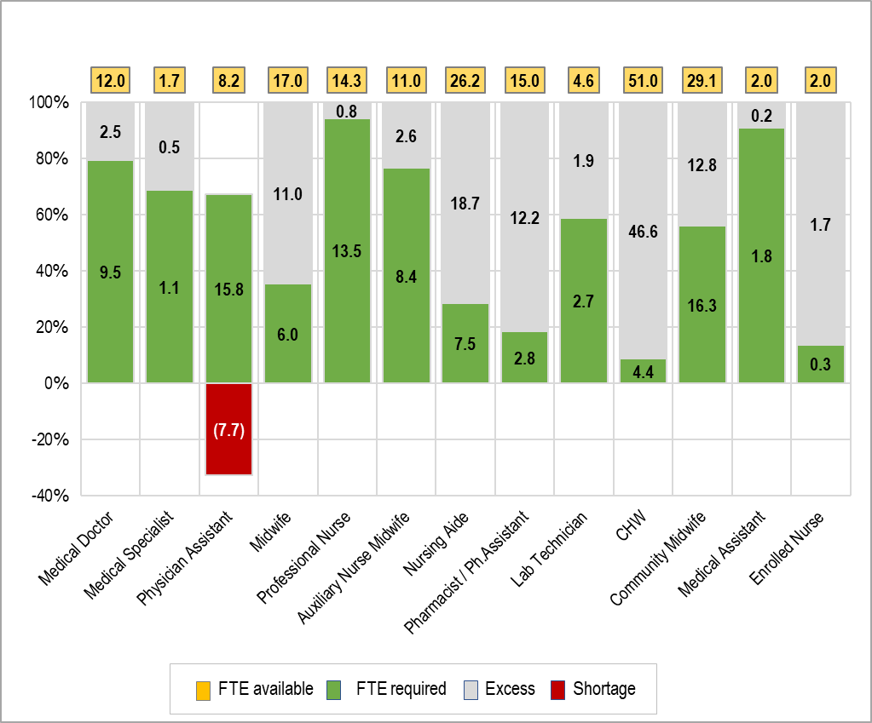

Figure 6. FTE summary by cadre for Dioila district at current patient volume (baseline)

Instead of changing task assignments on tab **4.a TA-Facility**, these changes will be made in a second task-sharing scenario on tab **6, Task Sharing**. This allows the comparison of FTE results before additional task-sharing (the baseline) and after more task-sharing (task-sharing scenario 2). The second task-sharing scenario will be applied to the potential client volume, which for now is identical to the baseline numbers as seen in column I on the **2. PHC Delivery** tab (ensure that the service modality scenario 2 is displayed). Figure 7 shows the FTE impact of reducing the percent of the patient volume handled by physician assistants (shaded yellow), which reduced the gap to about one compared to eight before the additional task-sharing. Professional nurses, enrolled nurses, and auxiliary nurse midwives are more efficiently utilized as a result.

The FTE impact can also be seen on the **DASHBOARD** by selecting the following as the user scenario 2 and examining the second, blue chart.

While working with aggregate district data shows the potential for task-sharing to reduce staffing gaps, the actual task-sharing must be performed in HOT4PHCs of individual health facilities. The **FTE Summary** tab helps select the HCs that have the staff necessary for task-sharing. Five HCs, Dioila, Fissaba, Massigui, Senou, and Wacoro, meet these criteria. After making the individual changes, the updated HOT4PHC files replace the older version in the folder from which all completed tools are imported into a district HOT4PHC.

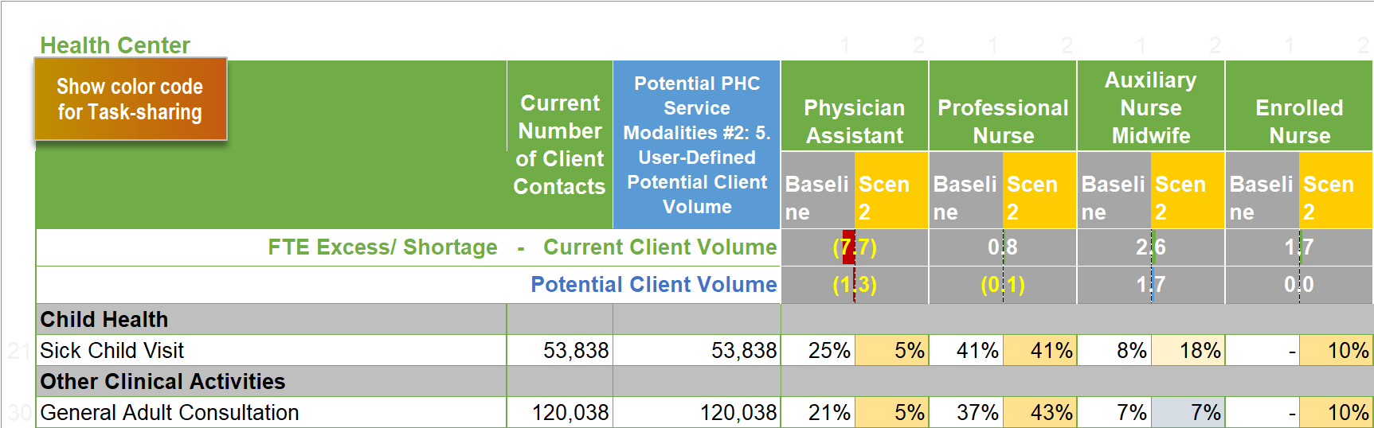

Figure 7. Task-sharing changes and FTE impact

In addition to calculating FTE requirements, HOT4PHC also estimates the costs for closing staffing gaps and to implement out-of-facility services as well as for community engagement and systems support activities. Salary, per diem and transport costs are country-specific and customized in tab **G, Cost Data**. The actual costs for closing staffing gaps and incidental cost for travel and overnight stays are shown on tab **7, Costs**. This costing tab requires very little user input but for a few budget numbers. In section 1 of tab **7, Costs**, additional funds required to cover existing and potential staffing gaps are shown, which are based on the 2 scenarios selected by the user on the **DASHBOARD**.

However, it is unlikely that governments can fill all gaps in the short run. A more realistic scenario is presented in sections 3 and 4 of tab **7, Costs**. The user enters funding available by source and determines which cadres should be priority hires and how many. HOT4PHC then show the user in section 4 how many additional staff can be hired within the existing budget envelop. This is not only calculated for salaries but also for per diem and transportation costs, which are shown in detail in section 2 of tab **7, Costs**. In this example, the budget envelop for salaries is $18,000. This would allow Dioila district to hire 2 physician assistants and 1 professional nurse. Where to allocate the staff would be determined based on the **FTE Summary** tab. Degnekoro and Wacoro HCs seem to be in greatest need of a physician assistant and Niantjila HC of a professional nurse. In this example per diem and travel costs face a major deficit. If no additional funds can be mobilized, community-based service delivery, community engagement and systems support activities such as supervision will be negatively affected. Training will usually not suffer, because it is often donor-funded.

## 3. Improving HRH Efficiency by Differentiating Service Delivery

*Case goal: Offer more community-based services to address HCW gaps & increase service utilization*

Instead of or in addition to task-sharing, service differentiation (the way or modalities through which PHC services are delivered) is another effective approach to optimizing the health workforce. HOT4PHC includes four PHC service delivery modalities: facility-based, community-based, mobile outreach, and collaboration with the private sector (the last two are hidden by the user on the **Start** tab because data related to these are not available in Mali). Service differentiation is a four-step process when starting with data that are aggregated across multiple health facilities.[5]

1. Use aggregated data to identify PHC tasks (activities) for service differentiation

***2. PHC Delivery***

***FTE Summary / FTE Chart***

***6. Task-sharing***

***Start***

***DASHBOARD (comparison of HRH scenarios)***

Figure 8. Tool Tabs used in this HRH efficiency case

1. Identify HCs with community-based providers that can differentiate services
2. Use the individual HOT4PHC files for these HCs to implement service differentiation
3. Reimport all individual HOT4PHC files to reaggregate data across all HC

The baseline scenario is the same as for the task-sharing scenario above. To illustrate the HRH impact of PHC service delivery differentiation, the third modality mix scenario with a patient volume identical to the baseline will be used. This allows for the comparison of HCW requirements and excess or gaps between the:

* Baseline (current patient volume scenario 1 and initial task assignment scenario 1)
* Task-sharing (modality mix scenario 2 and task sharing scenario 2)
* PHC delivery differentiation (modality mix scenario 3 and task sharing scenario 3)

To compare the baseline scenarios 1 with scenario 3 the user selects the following on the **DASHBOARD** tab:



Figure 9 on the next page, copied from tab **2, PHC Delivery**, shows that currently only vaccinations are delivered through a community-based modality. Assuming that HCWs delivering community-based services are qualified – possibly with additional training and adjustments to job descriptions – to also cover uncomplicated sick child visits, malaria case management and general adult consultations, the percent allocation between facility-based and community-based services is changed under Modalities #3 for these three tasks. Starting with tasks that take up most of HCWs’ time per column AL have the greatest impact on staffing needs.

Next, for tasks where client volume was shifted from facility-based to community-based service delivery modalities, these tasks need to be assigned to HCW to scenario 3 on tab **6, Task-sharing**, as shown in Figure 10. Sick child visits, malaria case management and general adult consultations are assigned to professional nurses, auxiliary nurse midwives, CHWs and community midwives; nursing aids also treat malaria cases but under supervision by professional nurses only. This improves the utilization of these cadres, especially community midwives as seen in the FTE excess or shortage comparison between scenarios 1 (current client volume) and 3 (potential client volume) in the top rows of Figure 10 in the next page.

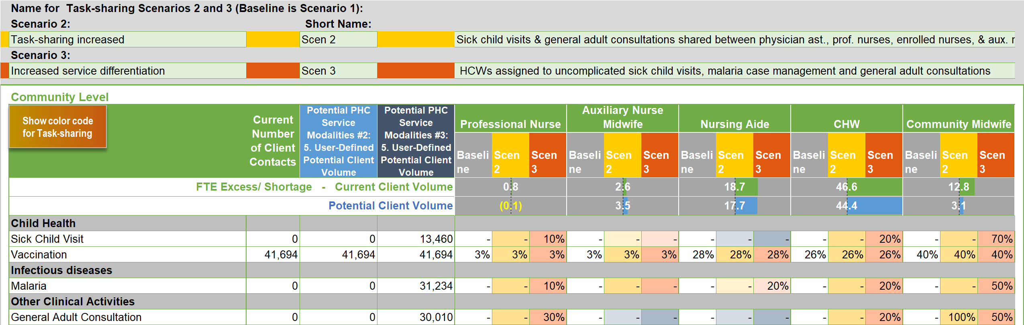

Figure 10. Task assignment to HCWs providing community-based PHC services under task-sharing scenario 3

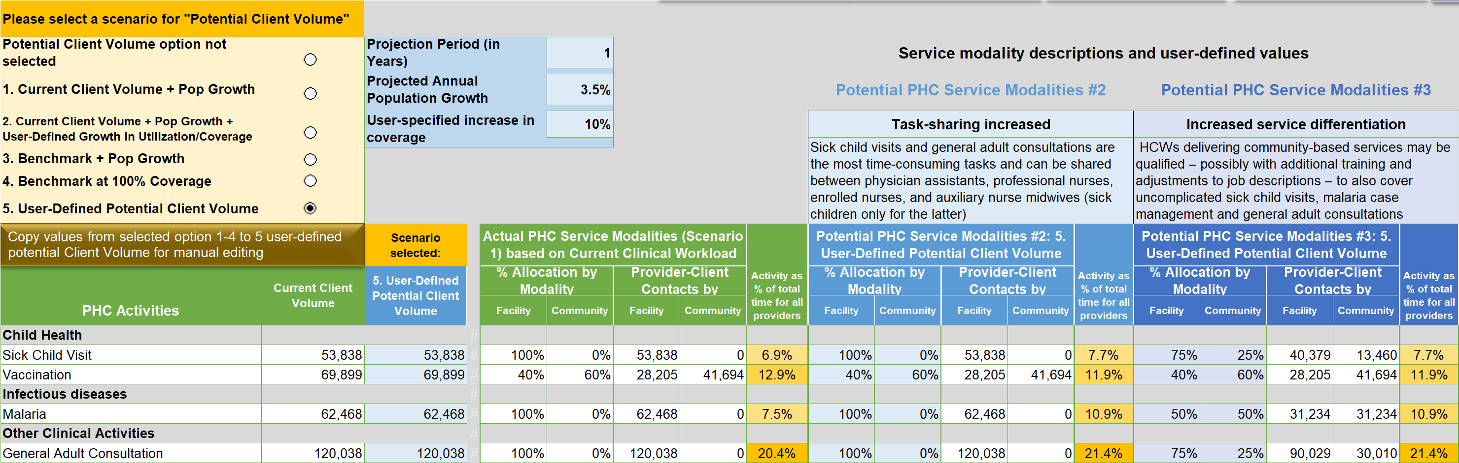

Figure 9. Service differentiation under PHC service modalities #3

Figure 11 from the **DASHBOARD** shows other effects of service differentiation on the health workforce. The gap of physician assistants is reduced from eight to four FTEs. Other cadres are less utilized, for example, physicians. However, it would not be unreasonable to expect overall service utilization to increase including facility-based services when community-based services are increased. Instead of keeping patient volume the same for all scenarios, an increase could have been applied by the user.

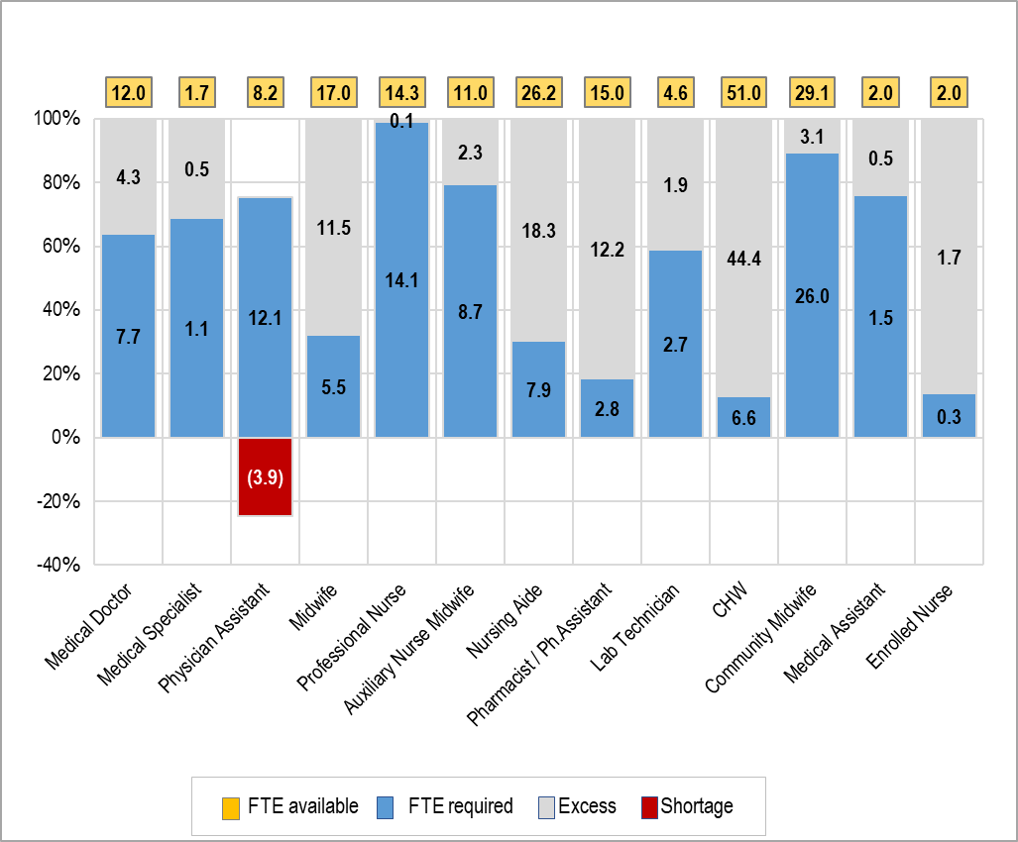

Figure 11. FTE summary by cadre for Dioila district, potential patient volume (scenario 3)

While working with aggregate district data shows the potential for PHC service differentiation to reduce staffing gaps and increase service utilization, the actual shift between service modalities must be performed in HOT4PHCs of individual health facilities. The **FTE Summary** tab helps select the HCs that have the staff necessary for differentiation. Only 10 of the 23 HCs in Dioila district have CHWs and community midwives, without whom HCs cannot effectively deliver community-based services except vaccinations. After making the individual changes, the updated HOT4PHC files replace the older version in the folder from which all completed tools are imported into a district HOT4PHC.

While the HRH efficiency cases of task-sharing and service differentiation were presented separately to demonstrate the effect on staffing for each change, in practice they may be combined. The combined HRH impact can be easily explored using HOT4PHC by making all changes in service modalities scenario #2 on tab **2, PHC Delivery** and task-sharing scenario 2 on tab **6, Task-sharing**. These changes can be applied to an increased patient volume on the **2. PHC Delivery** tab. At minimum, the volume should be adjusted to account for annual population growth by checking the second radio button from the top, because usually service data are from a previous year or older. Another increase specified by the user in the blue table to the right of the radio buttons can be added by checking the third button. The sixth button lets the user change the volume for each activity individually.

*Case goal: Show the degree to which the existing HCWs can absorb HIV/ART services from a dedicated,   
donor-supported workforce*

## 4. Assessing the HRH Impact of Integrating HIV/ART into PHC

The integration of HIV/ART services into PHC is demonstrated though a hypothetical scenario combining PHC data from Mali with HIV/ART data from Malawi, because Mali is a low HIV prevalence country where such an integration would not be applicable. ART service delivery models, tasks and client contact times are built into HOT4PHC and can be configured to a specific country’s context. The PHC data are the same as for the previous HRH efficiency cases. To display HIV/ART data, the user makes the appropriate selection on line 13 of the **Start** tab as seen in Figure 12.

This HRH efficiency case compares the staff requirements for a dedicated, possibly donor-funded, ART program with staff dedicated to ART service provision with staffing needs after integrating ART into PHC using existing clinic staff to the extent feasible.

The following two scenarios should be selected on the **DASHBOARD**:

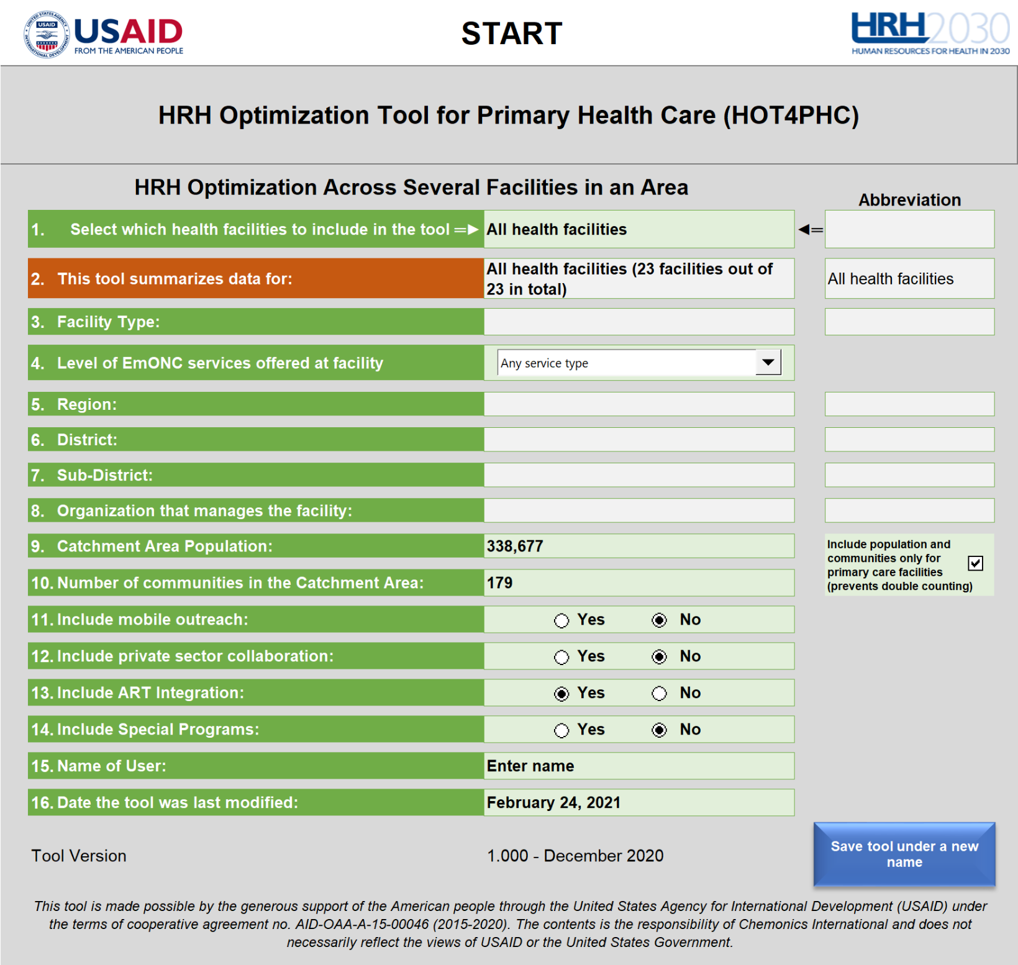

Figure 12. Selection of ART integration on the Start tab

## a. Scenario 1. Delivery of ART Services through Dedicated Staff

***Start***

***1. Client Volume***

***2.a ART Delivery***

***4.a Task Assignment (TA) - Facility***

***4.b Task Assignment (TA) - Community***

***6. Task-sharing***

***DASHBOARD (comparison of HRH scenarios)***

Figure 13. Tool Tabs used in this HRH efficiency case

Scenario 1, the baseline, starts with Figure 14 from tab **1, Client Volume**, which shows the ART client volume for several possible ART indicators (PEPFAR-specific indicators are in parentheses). This is followed by the distribution of ART clients across five possible ART service delivery models – standard care plus four differentiated service delivery (DSD) models. All four DSD models represent variations of multi-month dispensing or fast-track models (3 to 6 months) with an equivalent clinical appointment spacing. Each ART model can be configured for one of the four service modalities (facility, community, mobile outreach, and private sector) on tab **2.a ART Delivery** as shown in Figure 15.

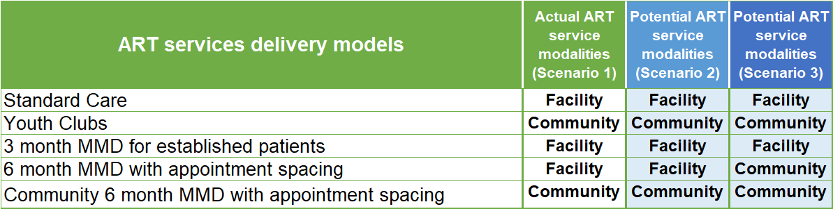

Figure . Type of service modality by ART service delivery model

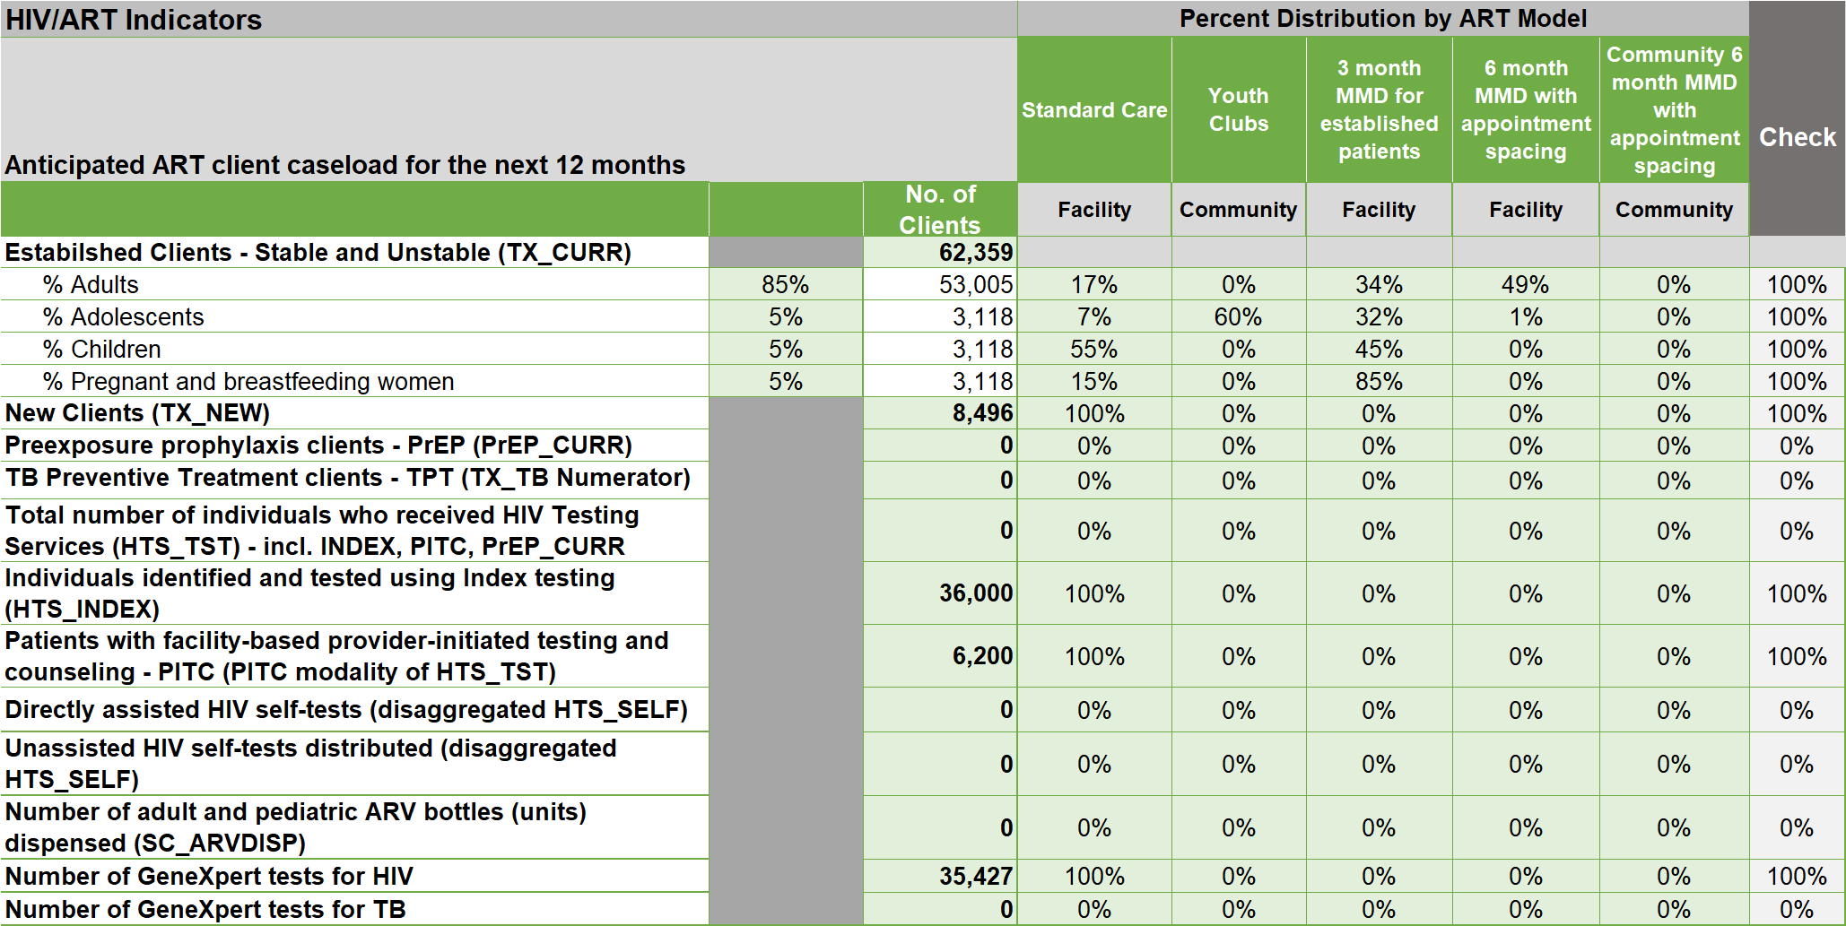

Figure 14. Client volume and distribution across ART service delivery models

In Figure 16, HOT4PHC then converts the client volume into the annual number of provider-client contacts and distributes these across the service modalities assigned in Figure 15. For example, there are 62,359 established and 8,496 new clients, which result in 281,240 ART consultations at the facility and 22,449 consultations in the community per year. The columns with blue headers will be used later for the integration scenario.

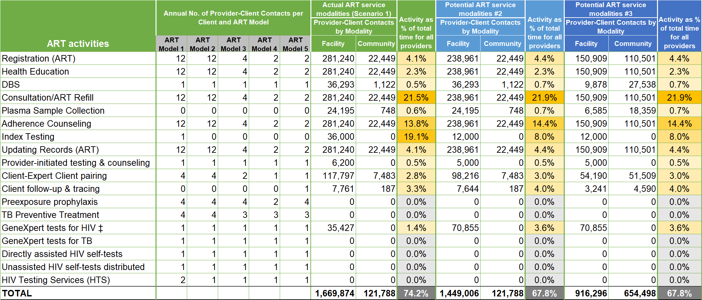

Figure 16. Annual client contact frequency by ART model and number of provider-client contacts by type of service modality

As shown in Figure 17 on the **DASHBOARD**, there are 578 FTEs available, 384 for ART and 194 for PHC. At the current client volume, 77 FTEs are required for clinical PHC activities and 334 FTEs for clinical ART activities. Together with 41 FTEs for community engagement and systems support activities this brings the total FTE requirement to 452 with 126 mostly PHC staff underutilized. The district has one GeneXpert diagnostic system with a 16-cartridge capacity, which is sufficient for testing about half of established and new ART clients annually. Adding a dedicated ART program without changing the delivery of PHC services does little to improve HRH efficiency, even though staff dedicated to ART is well utilized overall. Staff shortages or excesses are close to zero except for ART HTS providers.

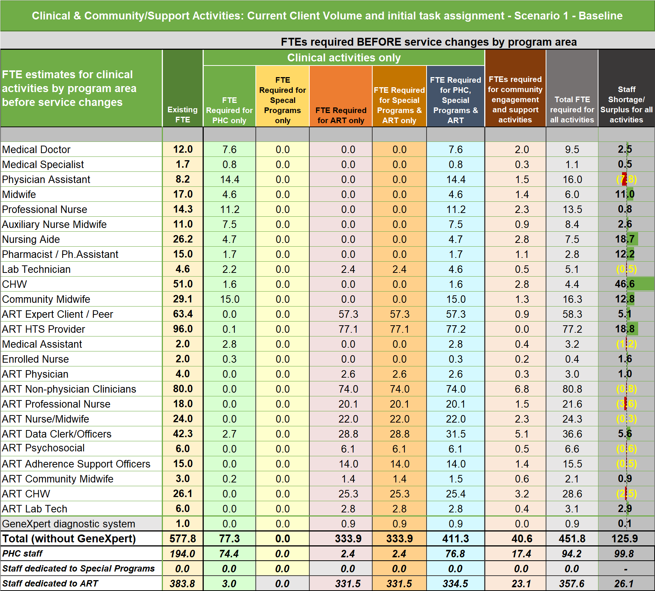

Figure 17. FTEs available & required for PHC and ART services under a dedicated ART program

## b. Scenario 2. Integration of ART services into PHC

The second scenario is about the integration of ART services into PHC. The first step is to revisit the client distribution across ART DSD models and explore whether more clients can be offered 3- or 6-months multi-month dispensing (MMD) options than is the case at baseline, which would not only serve clients better but would also lead to a more efficient utilization of a workforce that is in short supply. Three changes are made on tab **2.a ART Delivery** in Figure 18 on the blue side of the table. Firstly, all established adult clients on 3-month MMD are moved to 6-month MMD, which reduced the frequency of provider-client interactions by half for most ART activities. Secondly, an additional 25% of established child clients are moved from monthly standard care to 3-month MMD. Thirdly, 75% of stable new ART clients are offered 6-month MMD. The client volumes for scenarios 1 and 2 are identical except for GeneXpert tests, which doubled to ensure that all established and new patients have an annual viral load test.

These changes alone lead to a reduction of client contacts at the facility level by 13 percent as seen in the middle blue columns of Figure 17 and an almost 8 percent lower FTE requirement for implementing ART services comparing total FTE requirements for ART on the Service Modality Impact on HIV/ART tables in the **DASHBOARD**. The next step is to assign tasks from dedicated ART staff to PHC providers, which will most likely require additional ART training for the latter and possibly adaptations of their job descriptions. These assignments are done in the second scenario on tab **6, Task Sharing**. ART tasks are assigned at the facility and community levels based on the service modality selection on tab **2.a ART Delivery** in Figure 15. Using tab **6. Task Sharing** instead of tabs **4.a TA-Facility** and **4.b TA-Community** allows the comparison of the staffing requirements between the baseline scenario 1 with the shifts in task assignments under scenario 2. At baseline, none of the PHC staff were assigned to ART tasks, only dedicated ART staff was, except the laboratory technician. Under scenario 2, PHC staff with excess capacity was assigned a portion or all of certain ART tasks. However, this was not possible for all ART tasks such as consultations and ART refills, because insufficient PHC providers were available. ART tasks such as these and a several others still require additional providers although considerably fewer than under a dedicated ART program.



Figure 18. Change in client distribution by ART model between baseline scenario 1 and scenario 2 of ART integration into PHC

Figure 19 shows the staffing situation after integrating ART services into PHC. Overall, the ART integration and increased use of 3 and 6-months MMD described earlier reduce the FTE requirements by 38. However, a staff of 296 now includes PHC providers. This reduces the need for dedicated ART staff, especially some higher paid cadres such as non-physician clinicians, considerably from 332 to 241 FTEs. Of the 332 dedicated ART staff providing ART initially over a third, 117, would not be needed any longer. Dioila district would also need an additional GeneXpert diagnostic system to cope with the additional viral load tests. There are still some PHC providers that seem underutilized such as CHWs, but their time would be needed for scaling up community engagement and systems support activities, which can be explored using HOT4PHC. While pharmacists or assistants also show an excess, this may not be the case as this scenario does not consider their time for stocking, preparing, and logging ARV bottles.

The HRH efficiency case is complicated by the fact that ART services are not only delivered through service modalities, facility, community, etc., but also through five differentiated care models such as 3 and 6-month MMD. In addition to exploring ART service delivery separately, HOT4PHC also includes a special programs section that can be used in response to a public health emergency such as the COVID-19 pandemic. It is easier to apply than ART using HOT4PHC, because it simply extends the list of PHC tasks. However, the staffing situation is presented and analyzed in the same way as for ART integration in additional columns in Figure 17 and Figure 19. A HOT4PHC with sample data for a hypothetical COVID-19 response is available on the HRH2030 website.

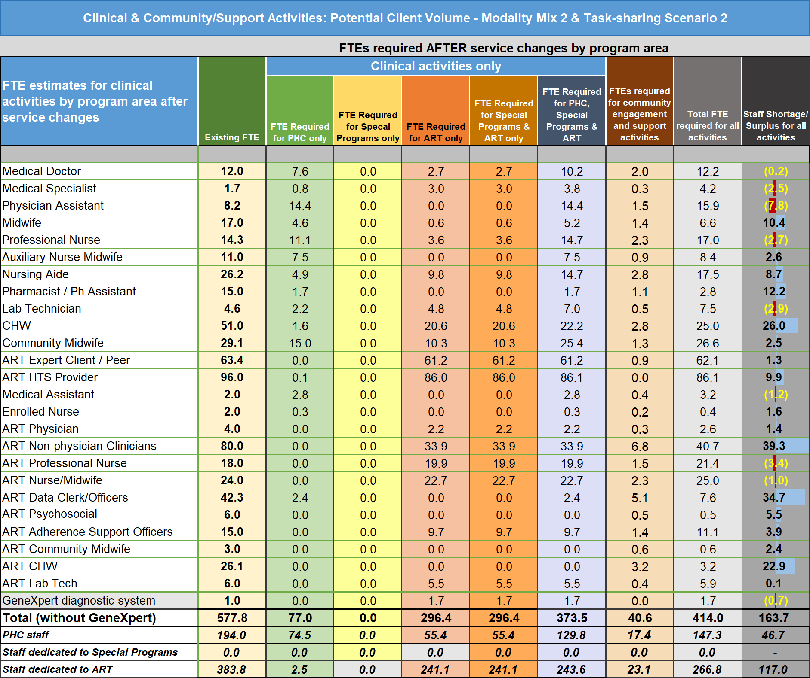

Figure 19. FTEs available and required after integrating ART services into PHC

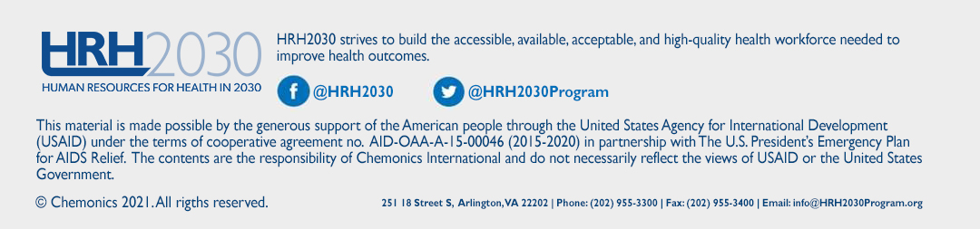HOT4PHC versions for these HRH efficiency cases can be found at: <https://hrh2030program.org/>. These tools present additional analyses beyond what is described in this document.

1. University Research Co. (URC), an HRH2030 partner, led the development of HOT4PHC (as well as HOT4FP and HOT4ART). All tools are available on the HRH2030 website: <https://www.hrh2030program.org/>)
2. User guides and other materials for the HOT4ART Tool may be found at <https://hrh2030program.org/tool_hrh-planning-for-hiv/>.
3. **Green tabs** starting with a letter are hidden and should only be changed by the team assigned to configure HOT4PHC, because these changes should apply to all HCs and not to individual facilities only. A new HOT4PHC file will be created for each HC that incorporates configuration changes and data already entered by the end-user.
4. When working with facility-level data, only steps three and four are needed.
5. When working with facility-level data, only steps three and four are needed.