

**HRH Optimization Tool for Primary Health Care (HOT4PHC)**

**Users Guide**

User Guide for Version 1 of the Tool (March 2021)

# Introduction

Providing client-centered primary health care (PHC) requires a strong, well-managed health workforce. In order to deliver effective healthcare—as well as to maintain essential primary care services during public health emergencies—it is important for health facilities, national Human Resources for Health (HRH), and implementing partners to use HRH data to determine how to best configure their health workforce and services. With funding from USAID, the Human Resources for Health in 2030 program (HRH2030) team created the HRH optimization tool for primary health care (HOT4PHC)[1] to increase health workforce efficiencies by identifying and addressing HRH bottlenecks at frontline health facilities. HOT4PHC supports comprehensive planning and management of a more adaptive and diverse health workforce for achieving universal health coverage.

# HOT4PHC Purpose

HOT4PHC helps improve workforce efficiencies by:

* Identifying HRH imbalances within and across health facilities
* Promoting patient-centered services through task-sharing and expanding service delivery beyond facility walls
* Strengthening community engagement and health systems support functions
* Configuring the health workforce in response to a public health emergency such as the COVID-19 pandemic
* Scaling up HIV antiretroviral therapy (ART) and tuberculosis control services and integrating them into PHC.

# HOT4PHC Audience

The results from HOT4PHC benefit stakeholders at all levels in the health sector:

* ***National and regional HRH planners and managers*** to secure funding for addressing HRH shortages, revise guidelines for community-based service delivery, budget realistically for systems support such as supervision, or adjust job descriptions to allow for greater task-sharing.
* ***District health management teams*** to identify gaps and balance its health workforce geographically, strengthening task-sharing and community-based service delivery and community engagement, and budget for supervision and additional staff in decentralized settings.
* ***Clinic managers*** to assess whether their healthcare workers (HCW) are sufficient and have the right skills set for coping with the patient volume, how coverage for critical services compares to national benchmarks, and what are HRH requirements and costs for scaling up and differentiating service delivery.

# HOT4PHC Implementation Process

While HOT4PHC can be learned and applied within a few hours to a single health facility using the generic version and the HRH efficiency cases (link), a customization process is recommended for a large-scale implementation in a specific country. In the latter case, implementation of HOT4PHC is led by a local HOT support team involving key stakeholders at service provider and administrative levels. It is an iterative process that fosters learning by providing new insights into a country’s health workforce, its efficiency challenges, and solutions.

The entire process may take between several weeks to six months, depending on the availability of stakeholders, the ready access to critical data elements (client volume, HRH inventory), the number of facilities involved, and the data issues encountered. If the preconfigured data for client-provider contact times for clinical activities and task-sharing practice can be applied without changes, the initial tool validation can be shortened. An upfront training is not required; partners learn during implementation. A training at the end is more beneficial because partners can use HOT4PHC with their data to identify and find solutions to correct HRH inefficiencies.

The entire process can be implemented by local partners with support from a small local HOT support team (2 persons) and some virtual external support. The local HOT support team helps with data collection and data entry and provides hands-on training.

Time estimates are based on the experience from implementing similar tools, HOT4ART and HOT4FP, in several countries. They account for the lead time for meetings and the time for iterative communication between stakeholders, the local HOT support team, and headquarters support. The following steps are involved. in the most intensive interaction with the tool takes place during steps 4 and 6.

***Stakeholder engagement to define the strategic importance and implementation plan***   
*What*: share information about HOT4PHC; stakeholder meeting; implementation plan  
*Who*: MOH, HRH department, civil service committee, Ministry of Finance, implementing partners, local HOT support team  
*Time required*: preparatory steps and a 2-hour stakeholder meeting over a 2-week period

***Tool validation and adaptation to a country context***  
*What*: convene expert provider groups, adapt HOT4PHC & data collection forms  
*Instruments*: HOT4PHC validation guide  
*Who*: expert providers, local HOT support team  
*Time required*: 3 expert group meetings (2 hours each) over a 2-week period, adaptation 1 week

***Data collection*** *(facility-specific using routine data such as DHIS2 and HRIS where available)*  
*What*: prioritize facilities, gather client volume, HRH, community engagement & support data  
*Instruments*: Service data form, Staff inventory, community engagement & support activities  
*Who*: MOH, HRH department, clinic managers, implementing partners, local HOT support team  
*Time required*: 2-8 weeks, depending on the number of facilities included and partner responsiveness

***Enter data into HOT4PHC (1 tool completed per facility)***  
*What*: copy and paste from data collection forms into HOT4PHC, adjust task assignments  
*Instruments*: completed data collection forms, HOT4PHC  
*Who*: local HOT support team and partners, headquarters support  
*Time required*: 1-2 weeks, depending on number of facilities included and data issues encountered

***Data import and validation***  
*What*: import facility HOT4PHCs into one multi-facility HOT4PHC; identify data issues/outliers  
*Instruments:* corrected data collection forms, HOT4PHC  
*Who:* local HOT support team and partners, headquarters support  
*Time required*: 2-4 weeks, depending on data issues met and responsiveness to clarify them

***Tool adjustments and data re-import***  
*What*: correct any significant data issues in facility HOT4PHCs; re-import into multi-facility tool  
*Instruments*: HOT4PHC  
*Who*: local HOT support team and partners, headquarters support  
*Time required*: 1-2 weeks, depending on the number of facilities that need adjustments to their data

***Data analysis and HRH situation analysis reports***  
*What*: identify HRH gap, surplus & cost; assess service efficiency; write summary report & PPT  
*Instruments*: HOT4PHC  
*Who*: local HOT support team and partners, headquarters support  
*Time required*: 2-4 weeks, including reviews and revisions of drafts

***Results dissemination, partner training and next steps***  
*What*: Stakeholder debriefing; tool training; planning solutions to address HRH inefficiencies  
*Instruments*: HOT4PHC  
*Who*: stakeholders, local HOT support team and partners, headquarters support  
*Time required*: 2 days for solutions plan; 1-2 stakeholder meetings (2 hours); 3-4-day training over 2-4 weeks

# Data Utilized to Illustrate Tool Use

The tool was tested in the Dioila district of Mali in November 2020. Its data are modified and utilized to illustrate the use of HOT4PHC. These data are for learning purposes only and are not meant to reflect actual health systems performance in Dioila district or Mali.

This guide is a step-by-step manual for how to use the tool. Another document presents HRH efficiency cases by providing examples and suggestions on how decision makers may leverage the HOT4PHC to identify solution to an inefficient employment of the health workforce. The HRH efficiency cases and tools with illustrative data are available on the HRH2030 [website](https://hrh2030program.org/tool_hrh-planning-for-hiv/).[2]

# Getting Started

HOT4PHC is an Excel-based tool (Excel 2010 or later). It is open source; there is no password protection, but users should only access the cells designated for data entry. HOT4PHC makes extensive use of macros. Macros must be enabled in Excel for the tool to work; and it must be saved as a macro-enabled file with the extension “,**xlsm**”. If ‘Enable Editing’ or ‘Enable Content’ appears on top of the spreadsheet, please click on these to enable full tool functionality. This is an Excel security feature that may show up depending on the user’s computer configuration.

HOT4PHC can be applied to a ***single health facility*** or it can be used as a master tool to import and aggregate data from ***multiple facilities*** at various levels such as districts, regions, or organizations managing facilities. The same version of HOT4PHC can be used in either of these manners; the **Start** tab shows which mode is selected.

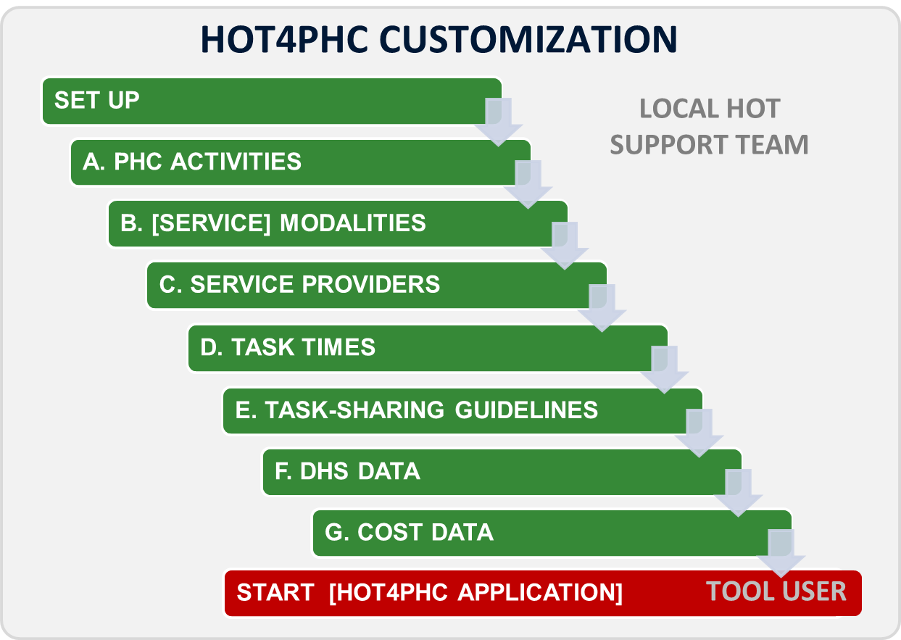

Figure 1. HOT4PHC Excel tabs for tool customization (green tabs)

# HOT4PHC Structure

HOT4PHC consists of 3 parts:

1. Tool ***customization*** for a specific country context on eight sheets, **Set Up and green tabs** **A – G**, as shown in Figure 1. These sheets are hidden and reserved for the local HOT support team and should not be changed by the tool user.
2. Tool ***application*** on 10 sheets, **Start and red tabs 1 – 5**, shown in Figure 2 that require essential user input on all visible tabs. Some of these sheets may be hidden depending on the options selected by tool users on the **Start** tab. Furthermore, users can explore two task-sharing scenarios on tab 6, **Task Sharing**, in addition to the initial task assignment on tabs **4.a – 4.d** (task-sharing scenario1). Tab **7, Costs**, shows the current salary costs, the potential costs of hiring additional HCWs to fill gaps, and costs related to the provision of community-based services, community engagement, and systems support such as supervision and training. Users can set priorities for filling staffing gaps and shortfalls in per diems and travel expenses based on the available budget envelop.

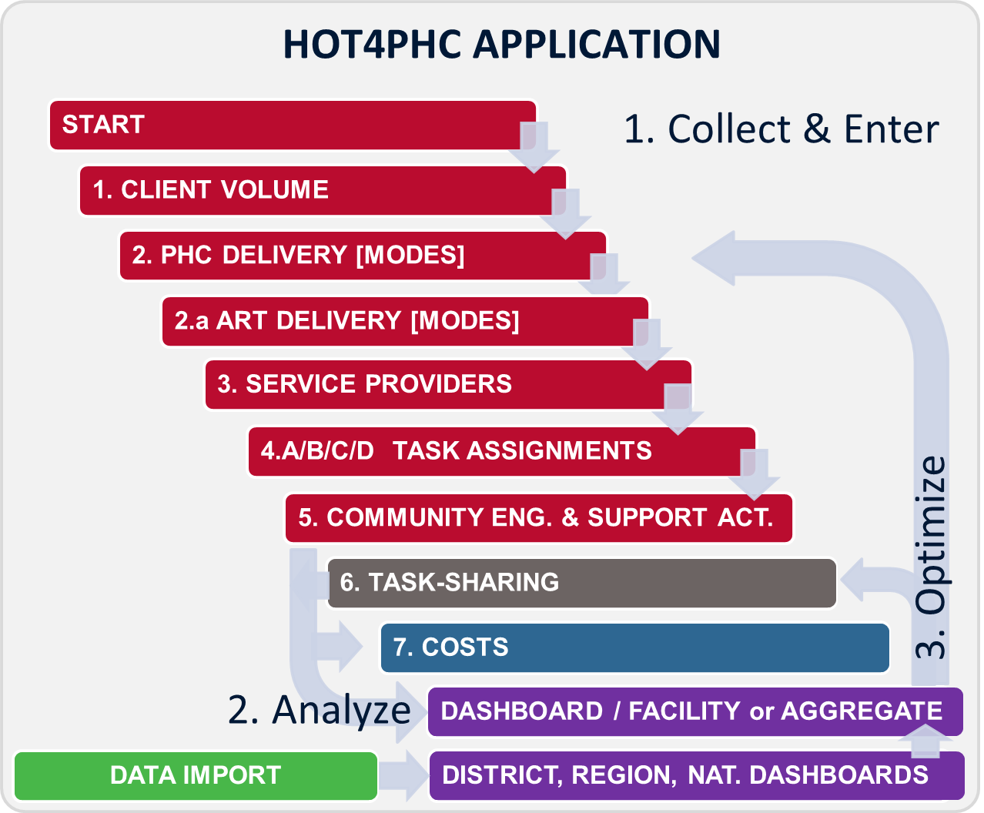

Figure 2. HOT4PHC Excel tabs for tool application

1. Essential ***HRH results*** such as FTE shortages or excesses are presented on most tabs to provide immediate feedback about any changes made by users. The **DASHBOARD** and several **multi-facility summary sheets on purple tabs** in Figure 3 provide a detailed analysis of HRH results. If the tool is used for a ***single health facility*** as selected on the **Start** tab, only the **DASHBOARD** shows. If ***multiple facilities*** are imported into HOT4PHC, the **DASHBOARD** and **multi-facility summary sheets** show. In this case the **DASHBOARD** will contain the aggregate data from multiple facilities as indicated on the **Start** tab. This can be the aggregate from all imported health facilities or for a subset of facilities if a filter is selected on the **FTE Summary** tab.

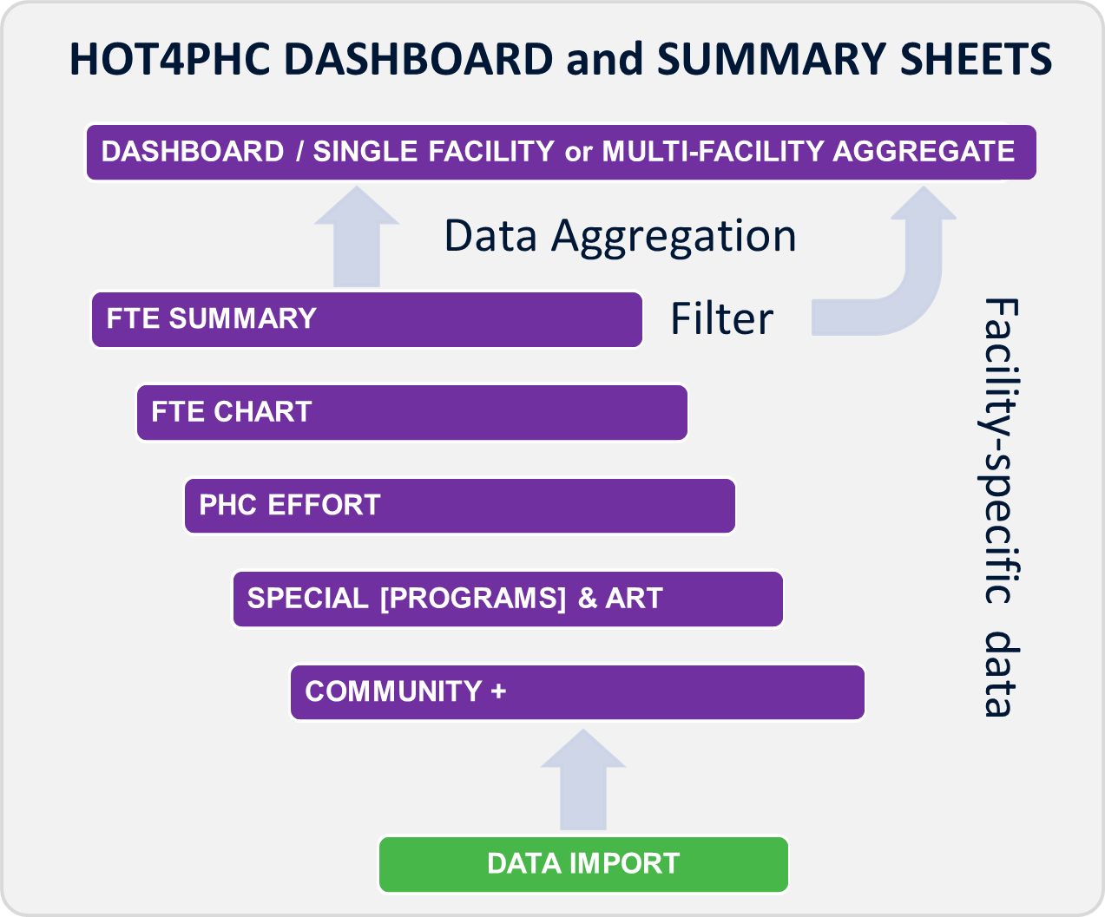

Figure 3. HOT4PHC Excel tabs for DASHBOARD and HRH results summary

The following will explain each sheet in detail starting with the ***HOT4PHC application***, **DASHBOARD,** and **multi-facility summary sheets**; HOT4PHC customization will be described last, because it is reserved for local HOT support teams.

# HOT4PHC Application

Throughout the tool, cells that are light green, light blue, light yellow, or light orange, indicate cells that allow user input, except on the **DASHBOARD** where they mostly contrast data in different table columns. Dark colors and white cells indicate protected cells that contain headings, descriptions, and formulas that cannot be changed by the user. **Green** generally indicates current client volume or baseline. **Blue** generally indicates potential client volume scenarios for comparison.

Some of the tabs contain light green cells with pre-populated data. It is possible for the user to override these inputs and insert values that are specific to his or her own context.

Light yellow text boxes on each tab contain specific instructions. The user should refer to these instructions before interfacing with the sheet.

Some calculations take time and **progress “>>>”** is displayed in the lower left of the Excel window. Please wait until the process is complete; do not manipulate Excel while it is calculating.

The following description is based on a master HOT4PHC with data imported from ***multiple health facilities***. It assumes that HOT4PHC has been customized to a specific country context, in this case Mali. This users guide is best used with HOT4PHC open because screenshots are not included for all tabs and tables.

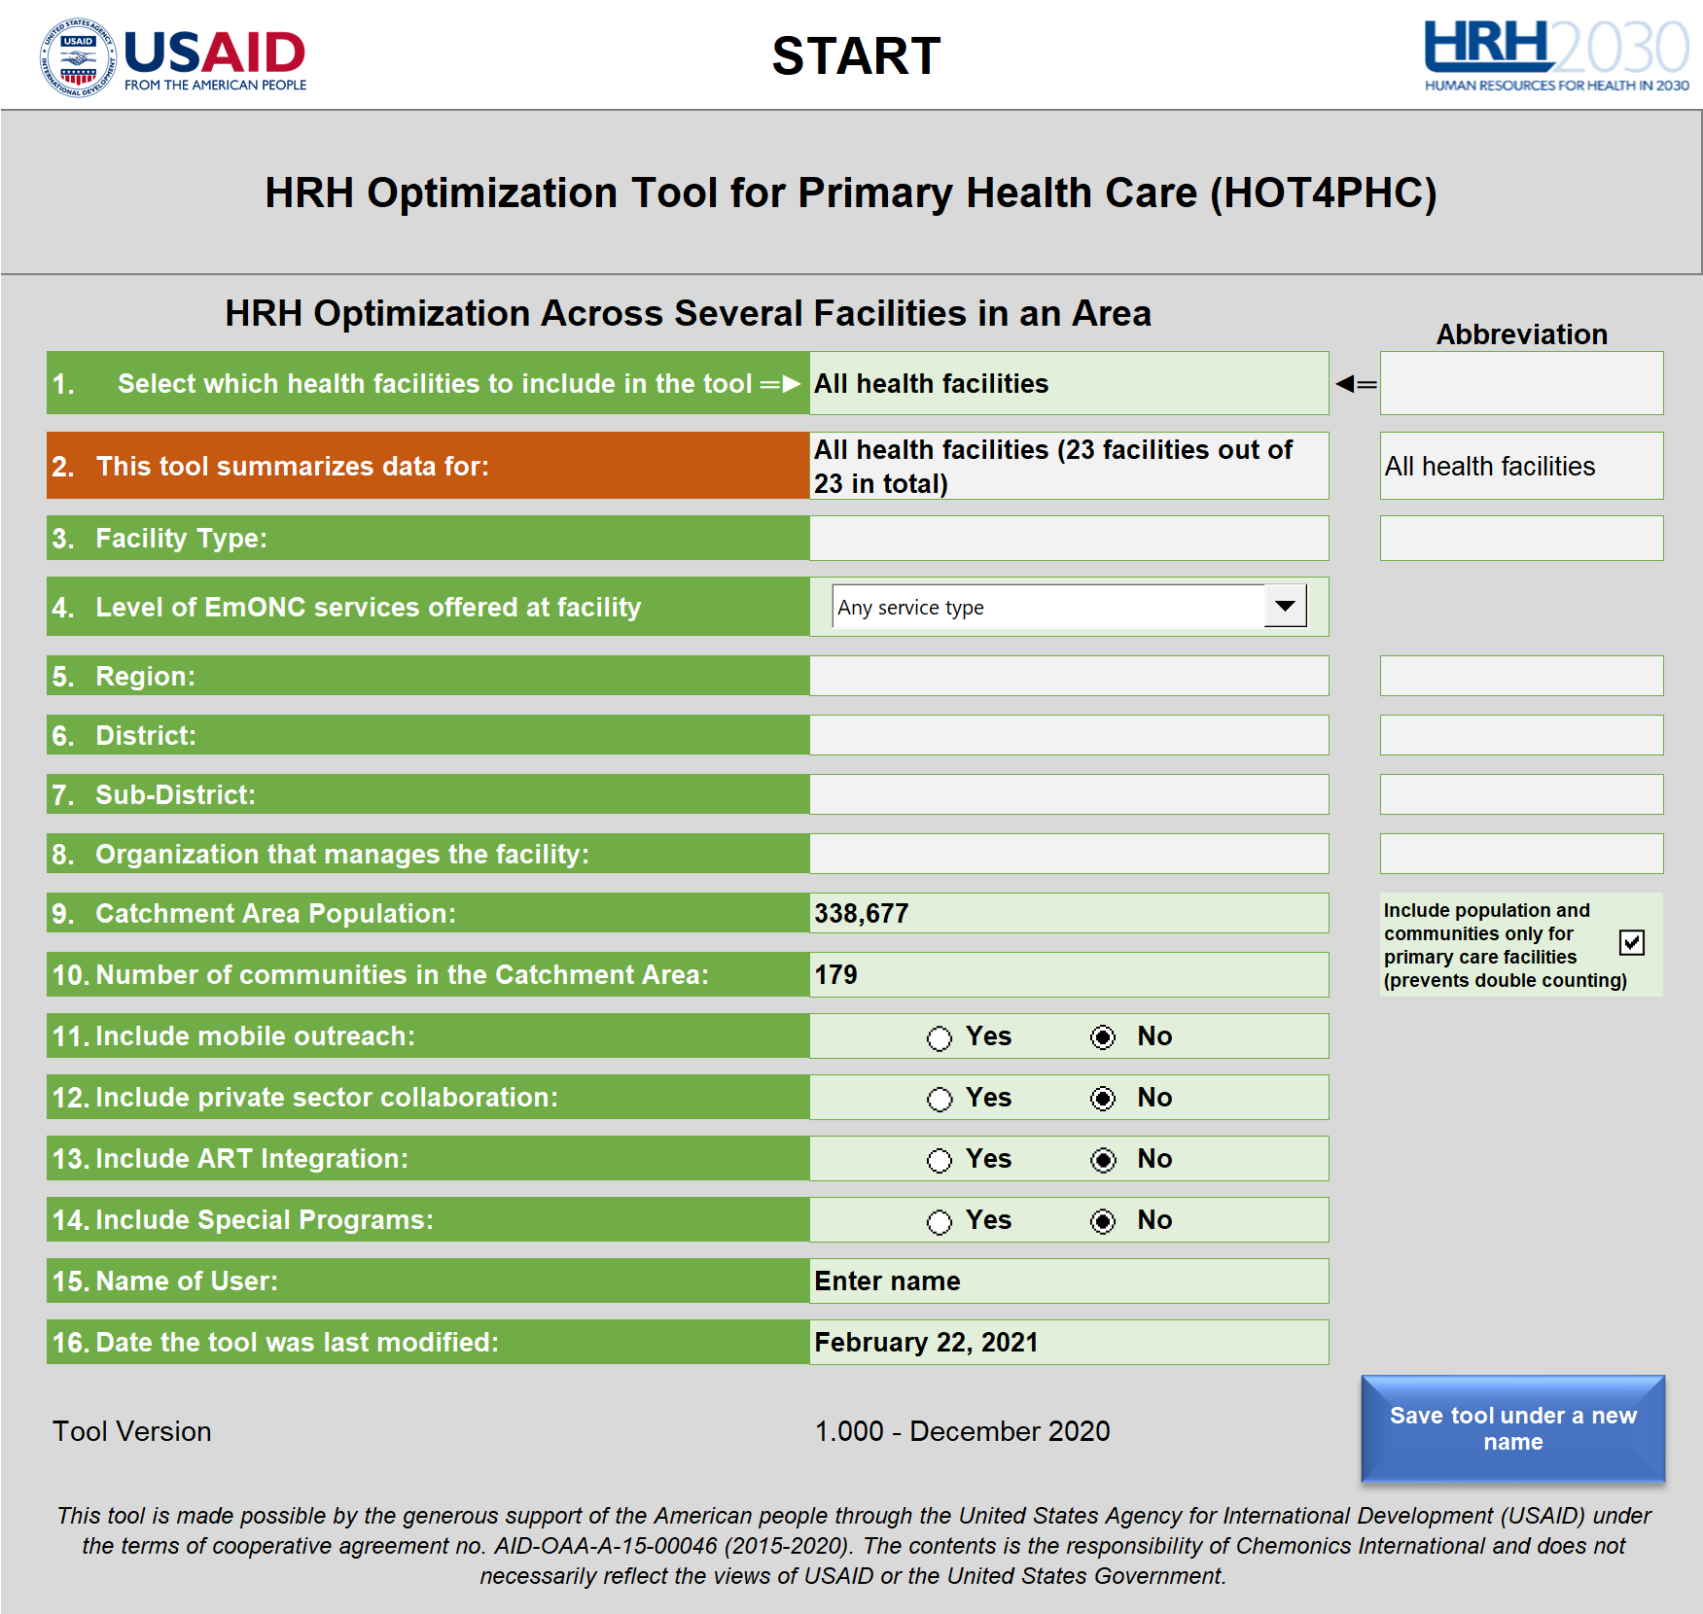

Figure 4. Start tab

## START TAB

Tool users begin data entry on this tab shown in Figure 4.

ACTIONS

Only change line 1 if creating a new tool; do not change when working in a tool with existing data.

Line 1: Select from the dropdown menu shown in. Creates a new tool for a single facility or a master tool with multiple facilities; user will be alerted if existing data will be erased. Do not change if working on an existing tool version. Each selection will trigger a tool action even when the same action is selected, but user can cancel. Figure 5 describes the options available.

Lines 11 through 14: Display or hide options based on country context. This simplifies the interface. The tool contains four PHC service modalities, facility, community, mobile outreach, and private sector; the first two will always show. Special programs and dedicated HIV/ART programs may only apply to some countries; if selected, they will require additional data.

|  |  |  |
| --- | --- | --- |
|  | **New tool or data import options\*** | **Description** |
| 1 | New health facility, no aggregation | Creates a new tool for a single health facility by erasing data on tab 1, **Client Volume** and tab 3, **Service Providers**. Select “Continue” on the prompt only AFTER information about the facility is completed on the **Start** tab. |
| 2 | All health facilities | Imports all tools for single health facilities saved in the folder specified by the user. Simplest way to import data from multiple facilities when the total number is less than 100. Importing more than100 is possible but takes time. |
| 3 | Region | Imports completed tools with the abbreviation for the region on line 5 in the filename. ** |
| 4 | District | Imports completed tools with the abbreviation for the district on line 6 in the filename. ** |
| 5 | Sub-district | Imports completed tools with the abbreviation for the sub-district on line 7 in the filename. ** |
| 6 | Organization | Imports completed tools with the abbreviation for the organization managing the facility on line 8 in the filename. ** |
| 7 | Facility-type | Imports completed tools with the abbreviation for the facility type on line 3 in the filename. ** |
| 8 | Any text (enter on the right) | Imports completed tools with any text in the abbreviation on line 1 in the filename. ** |
| 9 | Restore data from a single health facility | If the tool contains data from multiple health facilities, a new tool with data from each facility can be generated. Can be used to recreate single facility tools after HOT4PHC has been updated. ** |
| 10 | Create a new tool for every facility imported previously | To be used after an updated tool version becomes available. This is a two-step process. First, using the latest tool version and an option between 2 – 8, import all data for completed tools for individual health facilities into a master tool. Second, using option 10, recreate tools for the individual facilities. |
| *\*Importing data from multiple health facilities, options 2 through 8 above, can take less than one to several minutes per completed HOT4PHC tool, for example, the import of 100 tools could take an hour to several hours. Excel must not be used during this time until the entire process is completed, and the popup message disappears. Users can work with other programs such as email or MS Word, but not Excel, it is best to let Excel run its course over a break or overnight.*  *\*\*Text entered for options 3 through 8 above must match the entire or part of the abbreviation as in the filename.* | | |

Figure 5. Line 1 dropdown menu on the Start tab

If at some point data for Special Programs or HIV/ART have been entered, they can still be hidden. If they are hidden the data will be backed up and set to zero. If they show, the original data will be copied back. This is one way to show the staffing impact of special or HIV/ART programs.

DATA ENTRY (*when used for a single facility; in a master tool these will be populated automatically*)

Line 2: Enter the health facility name. Abbreviations are generated automatically but some can be edited.

Line 3: Select the type of facility from the dropdown menu.

Line 4: Designate Emergency Obstetric and Neonatal Care level (EmONC) from dropdown menu, which will show or hide certain PHC activities. Start with any “Any service type,” which shows all PHC activities.

Lines 5 through 8: Enter the names for the geographic areas. For Mali, they can be selected from dropdown menus. Abbreviations are generated automatically but some can be edited.

Line 9: Enter the population size of the facility catchment area for frontline facilities. Leave blank for referral facilities to avoid double counting when multiple facilities from a geographic area are imported.

Line 10: Enter the number of villages or communities in the facility catchment area for frontline facilities. Check for referral facilities to avoid double counting when multiple facilities from a geographic area are imported.

DATA ENTRY (*when used for a single facility or as a master tool*)

Lines 15 and 16: Enter the user’s name and date the tool was modified. The date will be part of the filename.



Figure 6. Tab 1, Client Volume

## 1. CLIENT VOLUME

This tab, Figure 6 (on the prior page), captures annual PHC service data. If selected by the user on the **Start** tab, data for special programs and HIV/ART services can be entered as well.

ACTIONS

*None*.

Hide or show the potential impact of a public health emergency is an advanced option used in conjunction with changes on the **DASHBOARD** tab.

DATA ENTRY

Enter the annual service volume for all available service modalities. This can be data from the latest available 12-month period or projections for the coming year.

DATA SOURCES

National health information systems such as DHIS2.

## 2. PHC DELIVERY

This tab shows the distribution of the client volume across up to four PHC service modalities, facility, community, mobile outreach, and private sector; the last two may be hidden depending on the selection on the **Start** tab. When using HOT4PHC for the first time, the tool starts in a basic mode showing only the distribution for the current client volume, which is sufficient to see if there is adequate staff or not to handle the current workload. The two graphs will only show data once tab **3**, **Service Providers** has been completed.

ACTIONS



Figure 7. Options for estimating the annual increase in potential client volume

*None* for the basic, scenario 1, application of HOT4PHC.

*Optional*: To show service modality scenarios 2 and 3, click the button on top of the sheet to reveal service modality scenario 2, which is based on a potential client volume (first light blue column). It will also show additional light blue columns where the user can distribute the potential client volume across available service modalities. A third service modality scenario can be added as well. The staffing needs for the three scenarios are compared on the **DASHBOARD**.

*Optional*: The source for the potential client volume is selected in Figure 7 by checking one radio button. Options 1 through 4 will increase the current client load by different amounts. Option 1 will account for the annual population growth. Option 2 will add a user-defined annual increase as specified in the small blue table (Figure 8). The projection period should be 1 for most tool uses, but can be increased, in which case population growth and annual increases are compounded annually. Options 3 and 4 are experimental and add demographic and health survey (DHS)-based benchmarks, which can lead to unrealistically high projections for the moment. In option 5, the user can specify a new volume for each PHC activity in column I. Users can switch between options without losing data. Option 1 is a good starting point for potential client volume scenarios 2 and 3.



Figure 8. Additional options for estimating the annual increase in potential client volume

*Optional*: The light blue table at the top of the sheet (Figure 8) gives users additional options for simulating the impact of PHC service delivery changes. First, users can select the projection period for estimating the potential client volume. This is followed by annual population growth and the estimated annual increase in service coverage (volume).

Hide or show unused PHC activities: This hides all activities with zero clients to simplify the table.

DATA ENTRY

*None* for the basic scenario 1.

*Optional*: Enter the title and description for service modality scenarios 2 and 3 (if the latter is shown) in the light blue text spaces.

*Optional*: Potential client volume for service modality scenarios 2 (and 3, if shown)

*Optional*: Client volume distribution across service modalities for scenarios 2 (and 3, if shown)

DATA SOURCES

The current client volume is taken from tab **1**, **Client Volume**.

Potential client volume can be projected by the user based on past trends and national health plans and strategies such as universal health coverage goals.

HRH RESULTS

After completing tab **3**, **Service Providers**, two charts in Figure 9 show the staffing situation for the **current** and **potential** client volume as full-time equivalents (FTE): existing FTEs, required FTEs, and FTE shortages or excesses. The charts display the staffing situation for two scenarios selectable by the user on the **DASHBOARD**. Each scenario is based on a different combination of current and potential client volume, PHC service modalities and levels of task-sharing.

A narrative summary on top of the charts shows where the most pressing FTE shortages or excesses are and what actions the user can take.

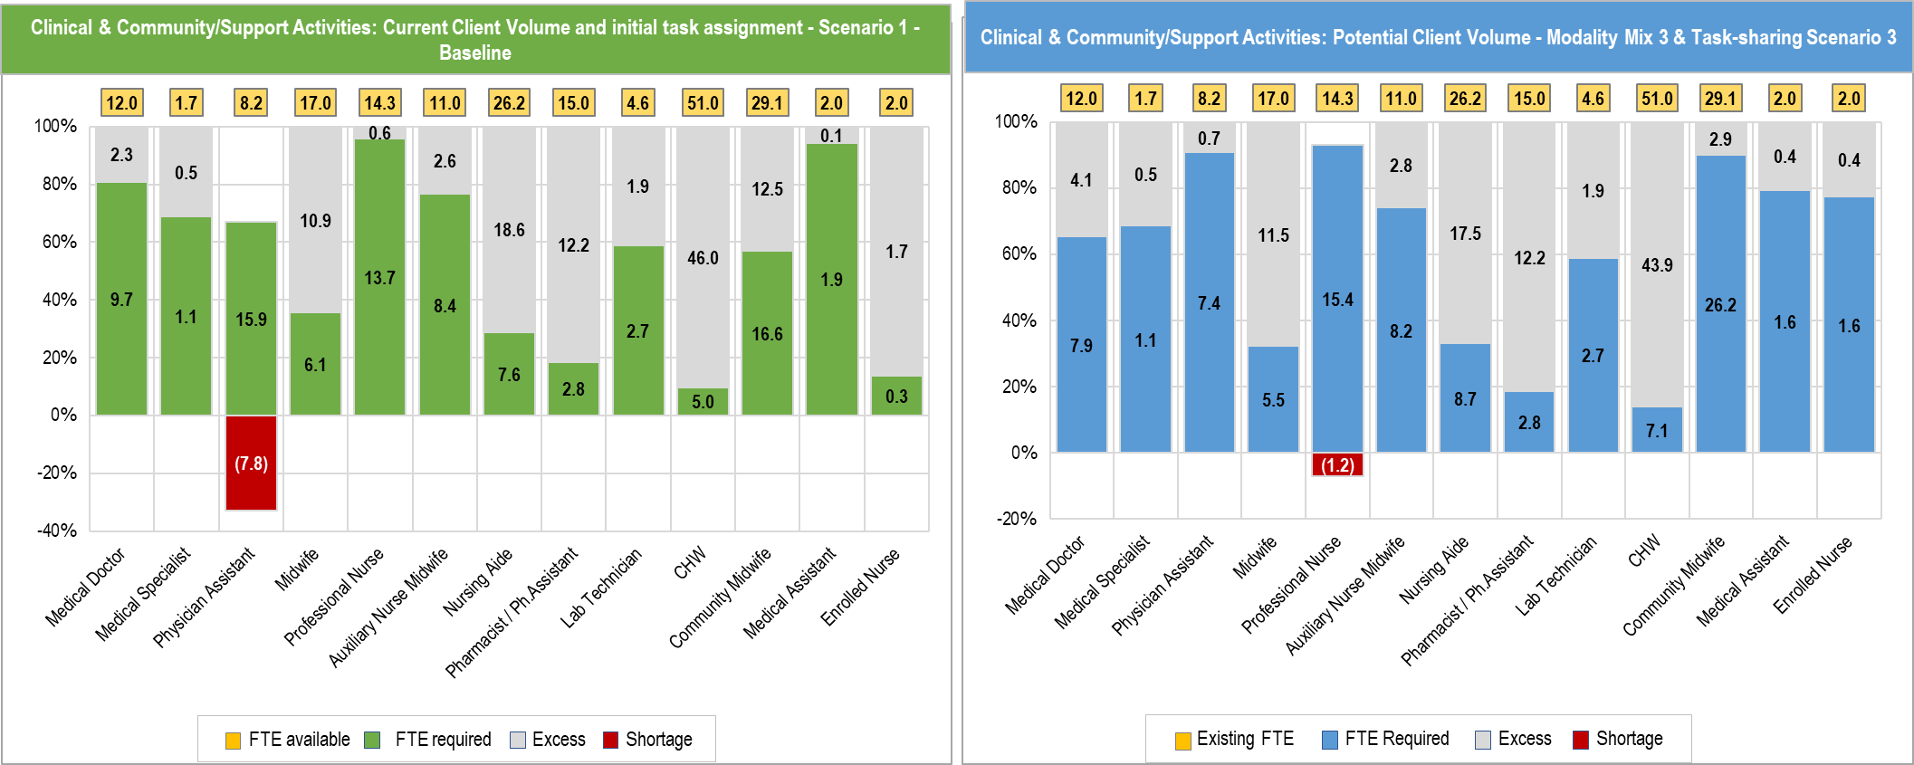

Figure 9. Staffing situation comparing two user scenarios

## 2.a ART DELIVERY

This tab, Figure 10, shows the client distribution for an HIV/ART program, if selected on the **Start** tab. The amount of information displayed depends on the selection on tab **2**, **PHC Delivery**, where the potential client volume and service delivery modality scenarios 2 and 3 may be hidden. HOT4PHC incorporates both ART models and service modalities. In addition to the four service delivery modalities (facility, community, mobile outreach, and private sector), HIV/ART services are also delivered through up to five models of care, for example, 3- and 6-month multi-month drug dispensing and youth clubs. Each ART model can be delivered through any of the four service modalities as shown in Figure 11. Most ART-related indicators are reported as client numbers, which are converted into client volume by the tool based on annual contact frequencies between clients and service providers. Firstly, the tool distributes clients across the five ART models as specified by the user on tab **1**, **Client Volume**. Secondly, these client numbers are converted to provider-client contacts or service volume for each ART model based on its service modality.

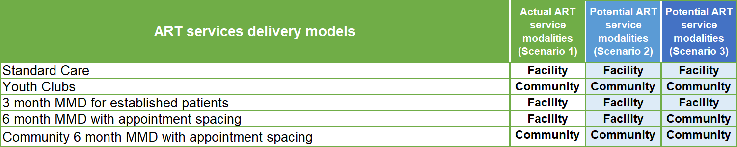

Figure 11. Service modalities by ART Model for up to 3 user scenarios



Figure 10. Client distribution for ART services by ART service delivery model

ACTIONS

*None* for the basic, scenario 1, application of HOT4PHC.

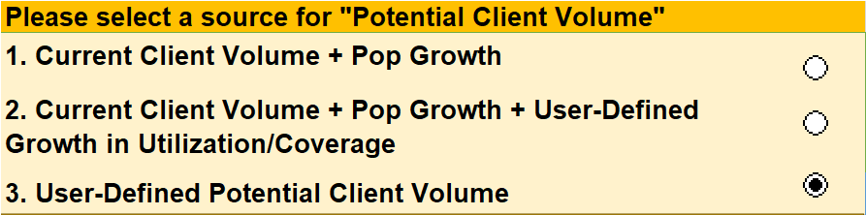

Figure 12. Options for estimating the annual increase in potential client volume

*Optional*: The source for the potential client volume is selected by checking one radio button in Figure 12. Options 1 through 3 will increase the current client load by different amounts. Option 1 will account for the annual population growth. Option 2 will add a user-defined annual increase as specified in the small blue table (Figure 8) on tab 2, **PHC Delivery**. The projection period should be 1 for most tool uses, but can be increased, in which case population growth and annual increases are compounded annually. In option 3, the user can specify a new client number for each ART service. Users can switch between options without losing data. Option 1 is a good starting point for potential client volume scenarios 2 and 3.

DATA ENTRY

*None* for the basic scenario 1.

*Optional*: Potential client numbers for service modality scenarios 2 in the light blue column F of section A.

*Optional*: Scale up of differentiated service delivery by distributing potential client numbers across ART models for service modality scenarios 2 and 3 in light blue columns R through V of section A.

*Optional*: Assign service modalities to ART models in section B for service modality scenarios 2 and 3.

Section C shows the client volume (provider-client contacts) distribution across service modalities for all three service modality scenarios.

DATA SOURCES

The current client volume is taken from tab **1**, **Client Volume**.

Potential client volume can be projected by the user based on past trends and national health plans and strategies for reaching the 95-95-95 targets of controlling the HIV epidemic.

HRH RESULTS

The staffing needs for the three scenarios are compared on the **DASHBOARD**.

## 3. SERVICE PROVIDERS

This tab, Figure 13 (on the following page), inventories all service providers at the health facility and their work hours.

ACTIONS

Click the “After entering all information, CLICK HERE to adjust the tool” button after making changes to this sheet.

*Optional*: Click “Show hours for part-time staff” only if there are entries in column P, else hide.

Hide or show unused staff: This hides all staff with zero availability or hours to simplify the table.

DATA ENTRY (rows 8 through 32)

*Columns D and E*: check whether staff is based at the health facility or in the community. Only mark one column or the other but not both.

*Columns F through I*: Enter “x” where staff can provide services for each of the four service delivery modalities as selected on the **Start** tab. Mark at least one column; marks in up to all four columns are allowed. Leave blank for staff not available at this facility.

*Column J*: input total available working hours in a week. This includes all clinical PHC and administrative tasks.

*Column K*: Input the average number of hours per week that each type of staff spends on PHC service delivery.

Column L: Shows the hours worked per week on administrative tasks. It is the difference between columns J and K; this is automatically calculated.

*Column M*: Enter the number of weeks worked in a year for each cadre.

*Column N*: Enter the total number of service providers for each cadre who are available for PHC service delivery. Do not count staff permanently absent (assigned on paper but not reporting for duty).

Column O: Of the service providers in column N, the tool tentatively assigns all these providers as working full-time.

*Optional Column P*: Enter the number of staff working part-time (less than the hours in column K). Click “Show hours for part-time staff.”

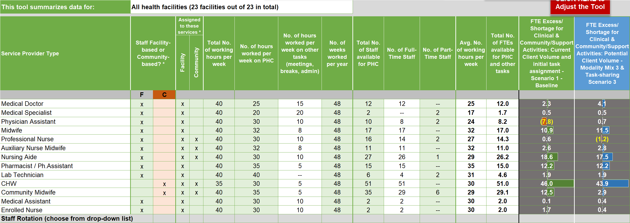

Figure . Service Providers tab

*Optional Columns Q through Z*: for each part-time staff enter the hours worked per week on delivering PHC services. ***Columns Q-Z must be filled for part-time staff to be counted.***

*Note*: Hours worked per week can be assigned for a maximum of 10 individual staff who work less than indicated in column K; if there are more than 10 in column P, each staff in excess of 10 will be assigned the same number of hours per week as the 10th staff in column Z.

DATA SOURCES

Human resource information systems (HRIS), HR databases, input from facility managers

DATA ENTRY (row 33)

*Optional*: Reserved for GeneXpert or similar polymerase chain reaction (PCR) diagnostic systems for HIV, tuberculosis, and potentially other pathogens. Requires the same information as staff.

DATA ENTRY (rows 35 through 39)

*Optional*: Reserved for staff rotation where staff from another facility is assigned to this facility. Select staff assigned from a dropdown list in column B. Requires the same information as regular staff. Their FTEs are added to regular staff above to calculate available FTEs and FTE shortages or excesses.

*Column AB*: Shows the full-time equivalents (FTE) available for PHC service delivery. FTEs are a combination of full and part-time staff; if all staff are full-time that an FTE is the same as the number of full-time staff.

*Columns AC and AD*: Show staffing gaps and surpluses as FTEs for the two scenarios selected by the user on the **DASHBOARD**. Any changes to the service provider inventory are immediately reflected in FTE shortages or excesses in these columns.

## 4.a TA-FACILITY

On this tab, Figure 14 (on the following page), the user assigns each clinical PHC task to a specific provider cadre at the health facility level. It is the average percentage of the client volume that is seen by a specific provider cadre. HOT4PHC guides task assignment through color coded cells (click the button to see the codes). Darker light green cells indicate that it is recommended that a specific cadre can perform a task per national or international guidelines. Lighter light green cells indicate that it is recommended that a specific cadre can assist in performing a task or under supervision only. Gray-blue cells indicate that a cadre is not recommended for performing a task. Gray cells indicate that a task was not yet designated to a specific cadre. The guidelines for task-sharing are configured on tab **E, Task Sharing Guidelines**.

ACTIONS

*Optional*: Select how task assignments are controlled. The option “As actually done” allows users to assign any task to any provider, even if this is not recommended per national and international guidelines. It is the best options for facility-level use of HOT4PHC; some facilities will simply not have the required staff. The option “As allowed by task-sharing guidelines” will prohibit the user from assigning a task to a cadre that is not recommended. This is a better option for district health management teams and above when working with aggregate data to explore HRH optimization options through task-sharing. The selected option will apply to all four task assignment tabs **4.a-d**.

*Optional*: Select whether to use actual or potential client volume in column AH for calculating the proportion that an activity time takes up overall. This helps focus on activities taking up most of HCWs time when setting priorities for task-sharing.

Hide or show unused PHC activities: This hides all activities with zero clients to simplify the table.

Hide or show unused staff: This hides all staff with zero availability or hours to simplify the table.

DATA ENTRY

*Column G*: For activities that can be done in groups such as health education enter the group size. For any activities involving the GeneXpert diagnostic system, enter the machine capacity (4, 16, etc.)

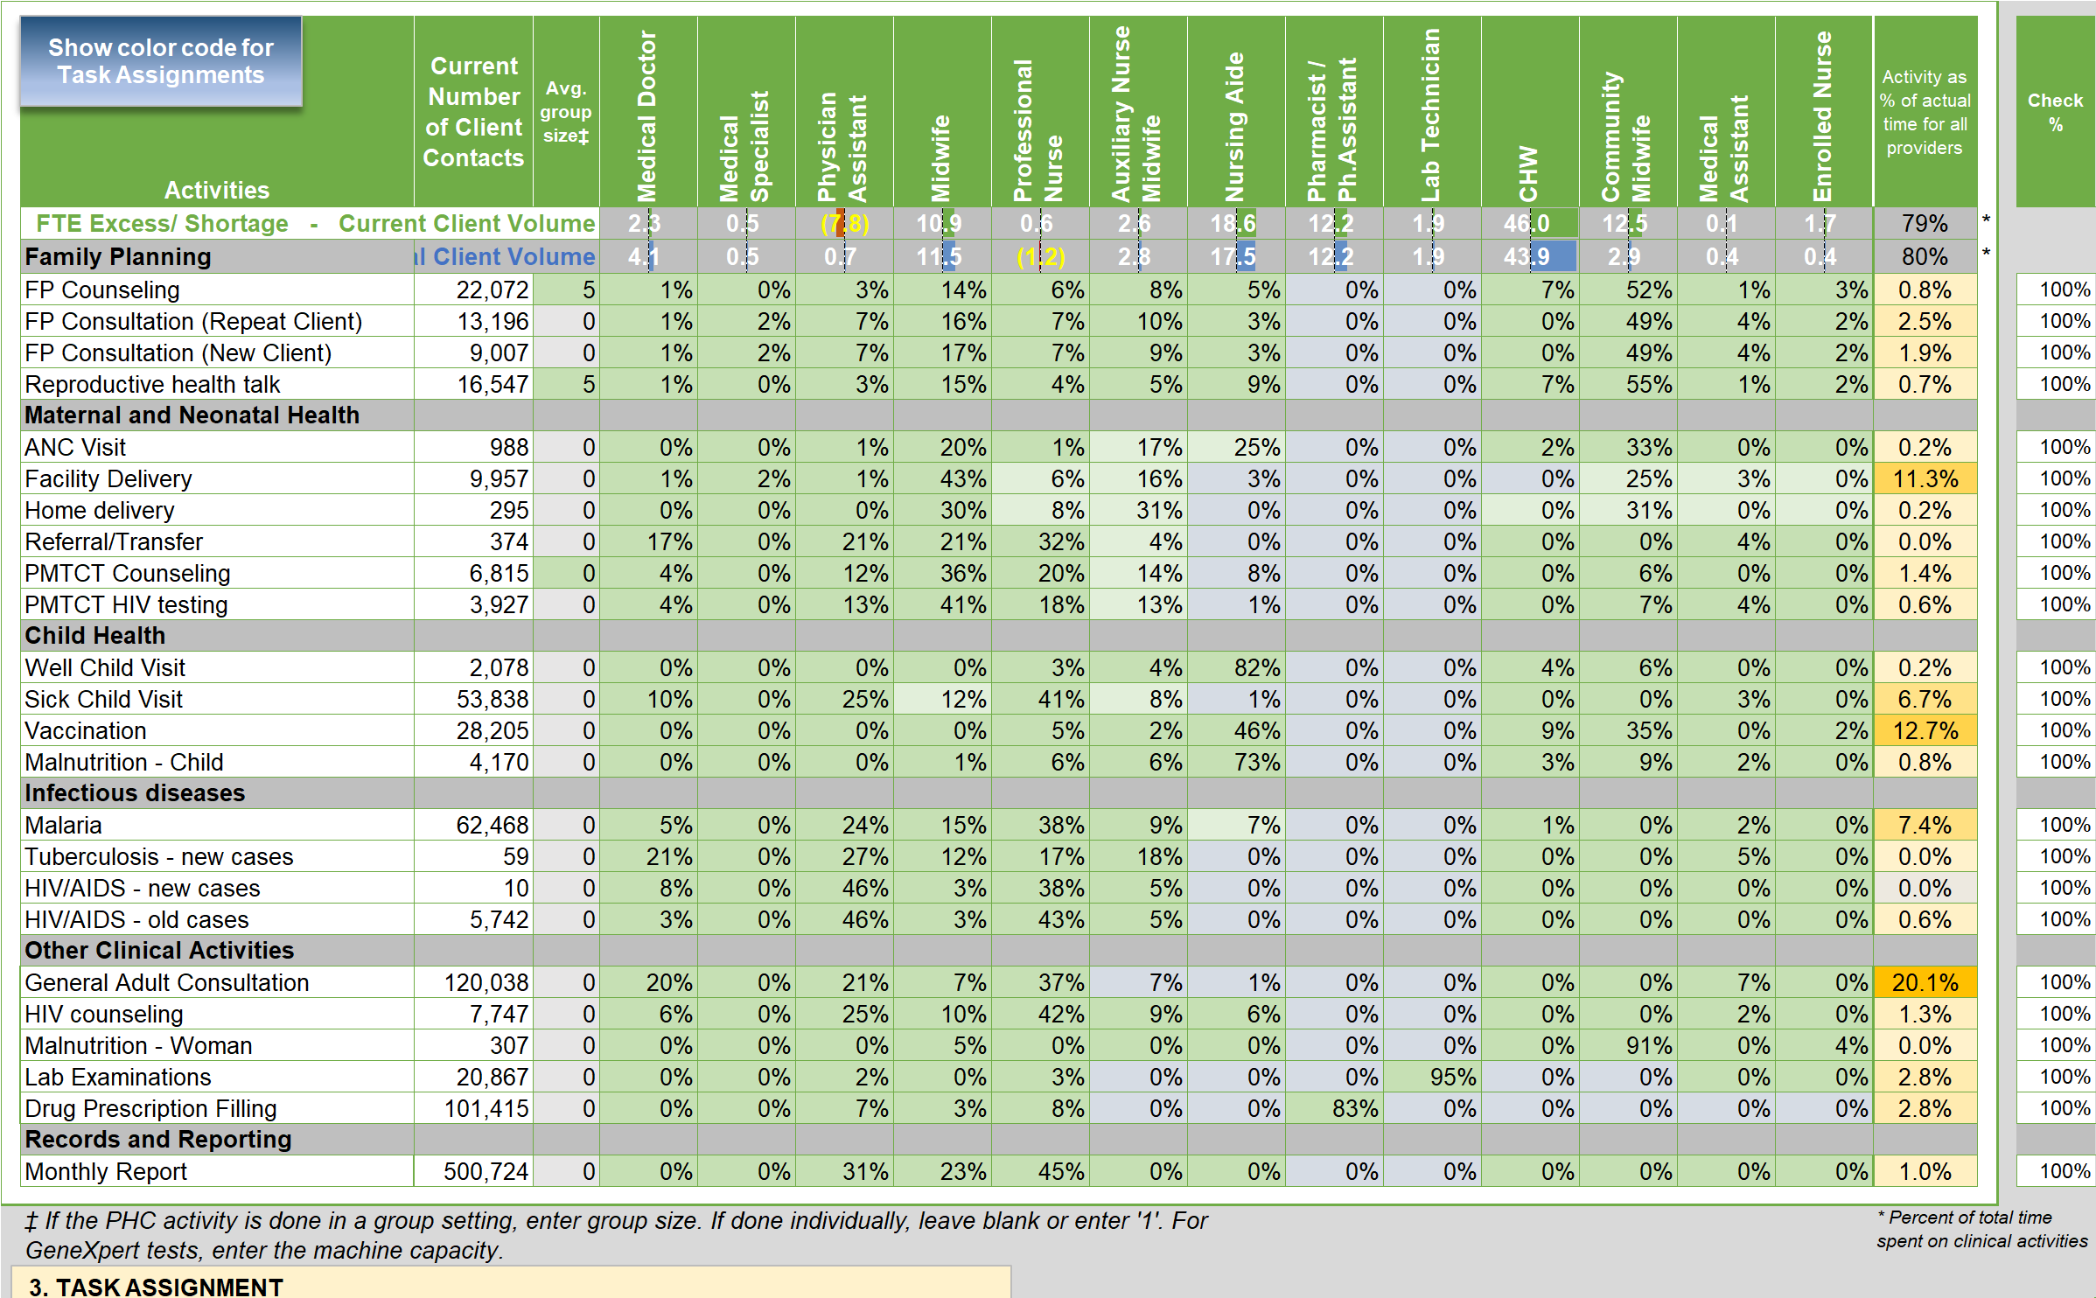

Figure . Health facility initial task assignment tab 4.a (some rows for Maternal and Neonatal Health tasks are hidden to fit the table to this page)

*Columns H through AG*: Assign a percentage of the client volume to each provider cadre. For activities done by a single provider, the percentages should add up to 100% in the last column. Some activities, such as antenatal care (ANC), are often done by more than one provider and percentages can add up to more than 100%. The total percentage should never be less than 100%.DATA SOURCES

Service provider expert group consultation, senior health professionals at the health facility

HRH RESULTS

*Rows 5 and 6*: Show staffing gaps and surpluses as FTEs by cadre for the two scenarios selected by the user on the **DASHBOARD**. Any changes to the task assignments are immediately reflected in FTE shortages or excesses in these rows.

Two charts show the same staffing situation but in greater detail for the two user scenarios as full-time equivalents (FTE): existing FTEs, required FTEs and FTE shortages or excesses.

*Column AH (next to the last)*: Shows which tasks take up the greatest percent of service providers’ time. Task-sharing for these tasks will show the greatest impact on staff shortages or excesses.

## 4.b TA-COMMUNITY

On this tab the user assigns each clinical PHC task to a specific provider cadre at the health community level. The ask assignments follow the same process as described under **4.a TA- Facility**. The following explains additional data needs for this tab.



Figure 15. Data entry for community-based PHC service delivery

DATA ENTRY (Figure 15)

*Cells D5 to D6*: Enter the number of clients seen by a HCW and by a CHW respectively for clinical PHC activities such as immunizations during work in the community.

*Cells D7 to D8*: Enter the number days in a month that a HCW and a CHW respectively spends in the community for clinical PHC activities such as immunizations.

The information in cells D5-8 is used to calculate travel-related expenses on tab **7, Costs**. This includes travel times between the health facility and community and within the community, which is entered on tab **5**, **Community & Support**.

## 4.c TA-OUTREACH

On this tab, the user assigns each clinical PHC task to a specific provider cadre for mobile outreach. The ask assignments follow the same process as described under **4.a TA- Facility**. The following explains additional data needs for this tab.

DATA ENTRY

*Optional Rows 6 through 10*: Select external providers that conduct mobile outreach, if applicable, from a dropdown menu. This applies mostly when an external team visits the health facility to provide specialized service not available routinely. The number of clients seen is counted as part of the services delivered by the health facility.

*Cells G12 and G13*: Enter the number of clients seen per mobile outreach visit and the average number of hours for a mobile outreach visit.

## 4.d TA-PRIVATE Sector

On this tab, the user assigns each clinical PHC task to a specific provider cadre at a private healthcare facility. The ask assignments follow the same process and its structure is identical as described under **4.a TA-Facility**.

## 5. COMMUNITY & SUPPORT

On this tab, the user performs two tasks. First, the number of events realized and planned per year related to community engagement, supervision, continuing education, and drug supply are entered. Second, the events are assigned to specific service provider cades – split between cadres based at the health facility and those in the community. Tasks are assigned as the percentage of the event similar to the assignment of clinical tasks above.



Figure 16. Community engagement and systems support activities realized and planned

DATA ENTRY (Figure 16)

*2nd Column*: Average number of events ***realized*** per year in ONE community where community-based activities are supported, which usually means that there is a at least one community-based worker such as a CHW or community midwife.

*3rd Column*: Average number of events ***planned*** per year in ONE community where community-based activities are supported. This is equivalent to 100% coverage.



Figure 17. Community engagement and systems support task assignment, level of effort and activity duration

*4th Column (community engagement only)*: Number of communities covered, which usually is less or equal to the number of communities with at least one community-based worker such as a CHW or community midwife.

*5th Column*: Average number of people reached per event (light green cells only).

*Columns N through BK in Figure 17*: Assign a percentage of the events to each provider cadre. Percentages do not have to add up to 100%, because multiple cadres may be involved in these activities.

*Optional columns BV through BY*: Adjust the times required per event (average, minimum and maximum), if necessary.

*Optional table CK1 to CW8*: This table, Figure 18, calculates the number of households to be visited per year in one community. The average number of households per community is given as a reference. The user has three options (1) set a fixed number; (2) set a percentage of households in a community; or (3) use a needs-based approach. If the third option is selected, up to six criteria shown in Figure 19 can be applied depending on national guidelines. The table shows all the calculations required to determine how many households should be targeted.



Figure 18. Three options for calculating household visits

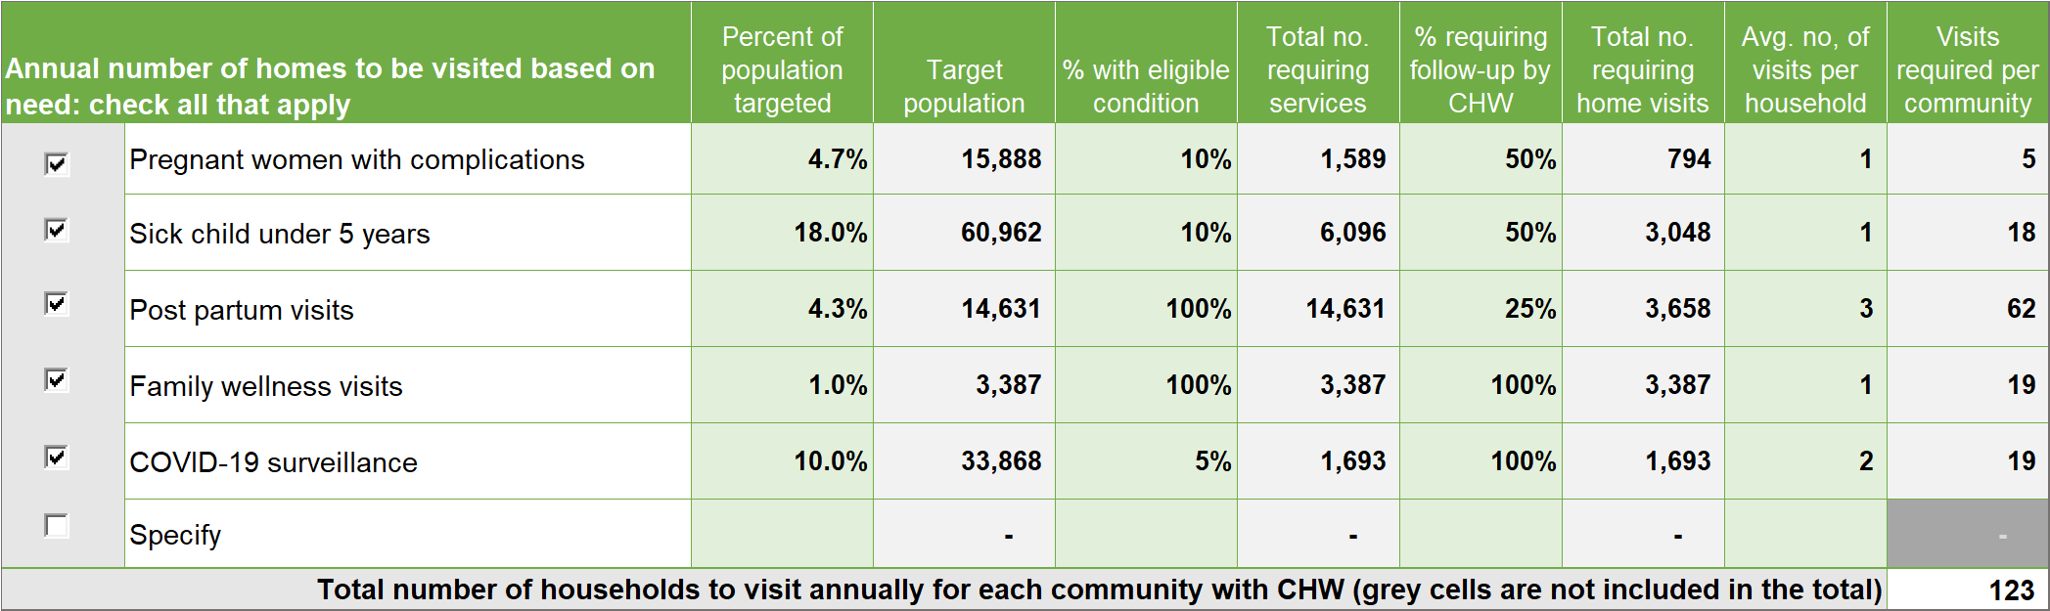

Figure 19. A needs-based approach for estimating the number of households to be visited annually

DATA SOURCES

Service provider expert group consultation, senior health professionals at the health facility

HRH RESULTS

*Rows 11 and 12*: Show staffing gaps and surpluses as FTEs by cadre for the two scenarios selected by the user on the **DASHBOARD** except for the second scenario, which is based on a 100% coverage (planned events) for community engagement and systems support (clinical activities are the same). Any changes to the task assignments are immediately reflected in FTE shortages or excesses in these rows.

*Column K*: Shows the percent of planned events that were realized.

*Column BL and BM*: Show which tasks take up the greatest percent of service providers’ time. The first column applies to current coverage levels (events realized); the second column applies to 100% coverage levels (events planned).

*Cells H6 to M7 in Figure 20*: Summarize how much time providers spend on community engagement, supervision, continuing education, and drug supply and how their time is split between these activities and clinical PHC activities.



Figure 20. Provider time split between clinical tasks and community engagement and systems support activities

## 6. TASK SHARING (*optional*)

On this tab users can create two task-sharing scenarios – 2 and 3 – in addition to the initial task assignments (scenario 1) on tabs **4.a – d**.

ACTIONS

Select whether to show or hide the third task-sharing scenario by clicking the button to top of the sheet.

Users can opt to only display PHC activities and staff in use at this facility by clicking the appropriate button on top of the sheet, which simplifies the tables greatly. Shrinking tables by displaying only activities with a volume greater than zero and only staff assigned to these activities takes a moment.

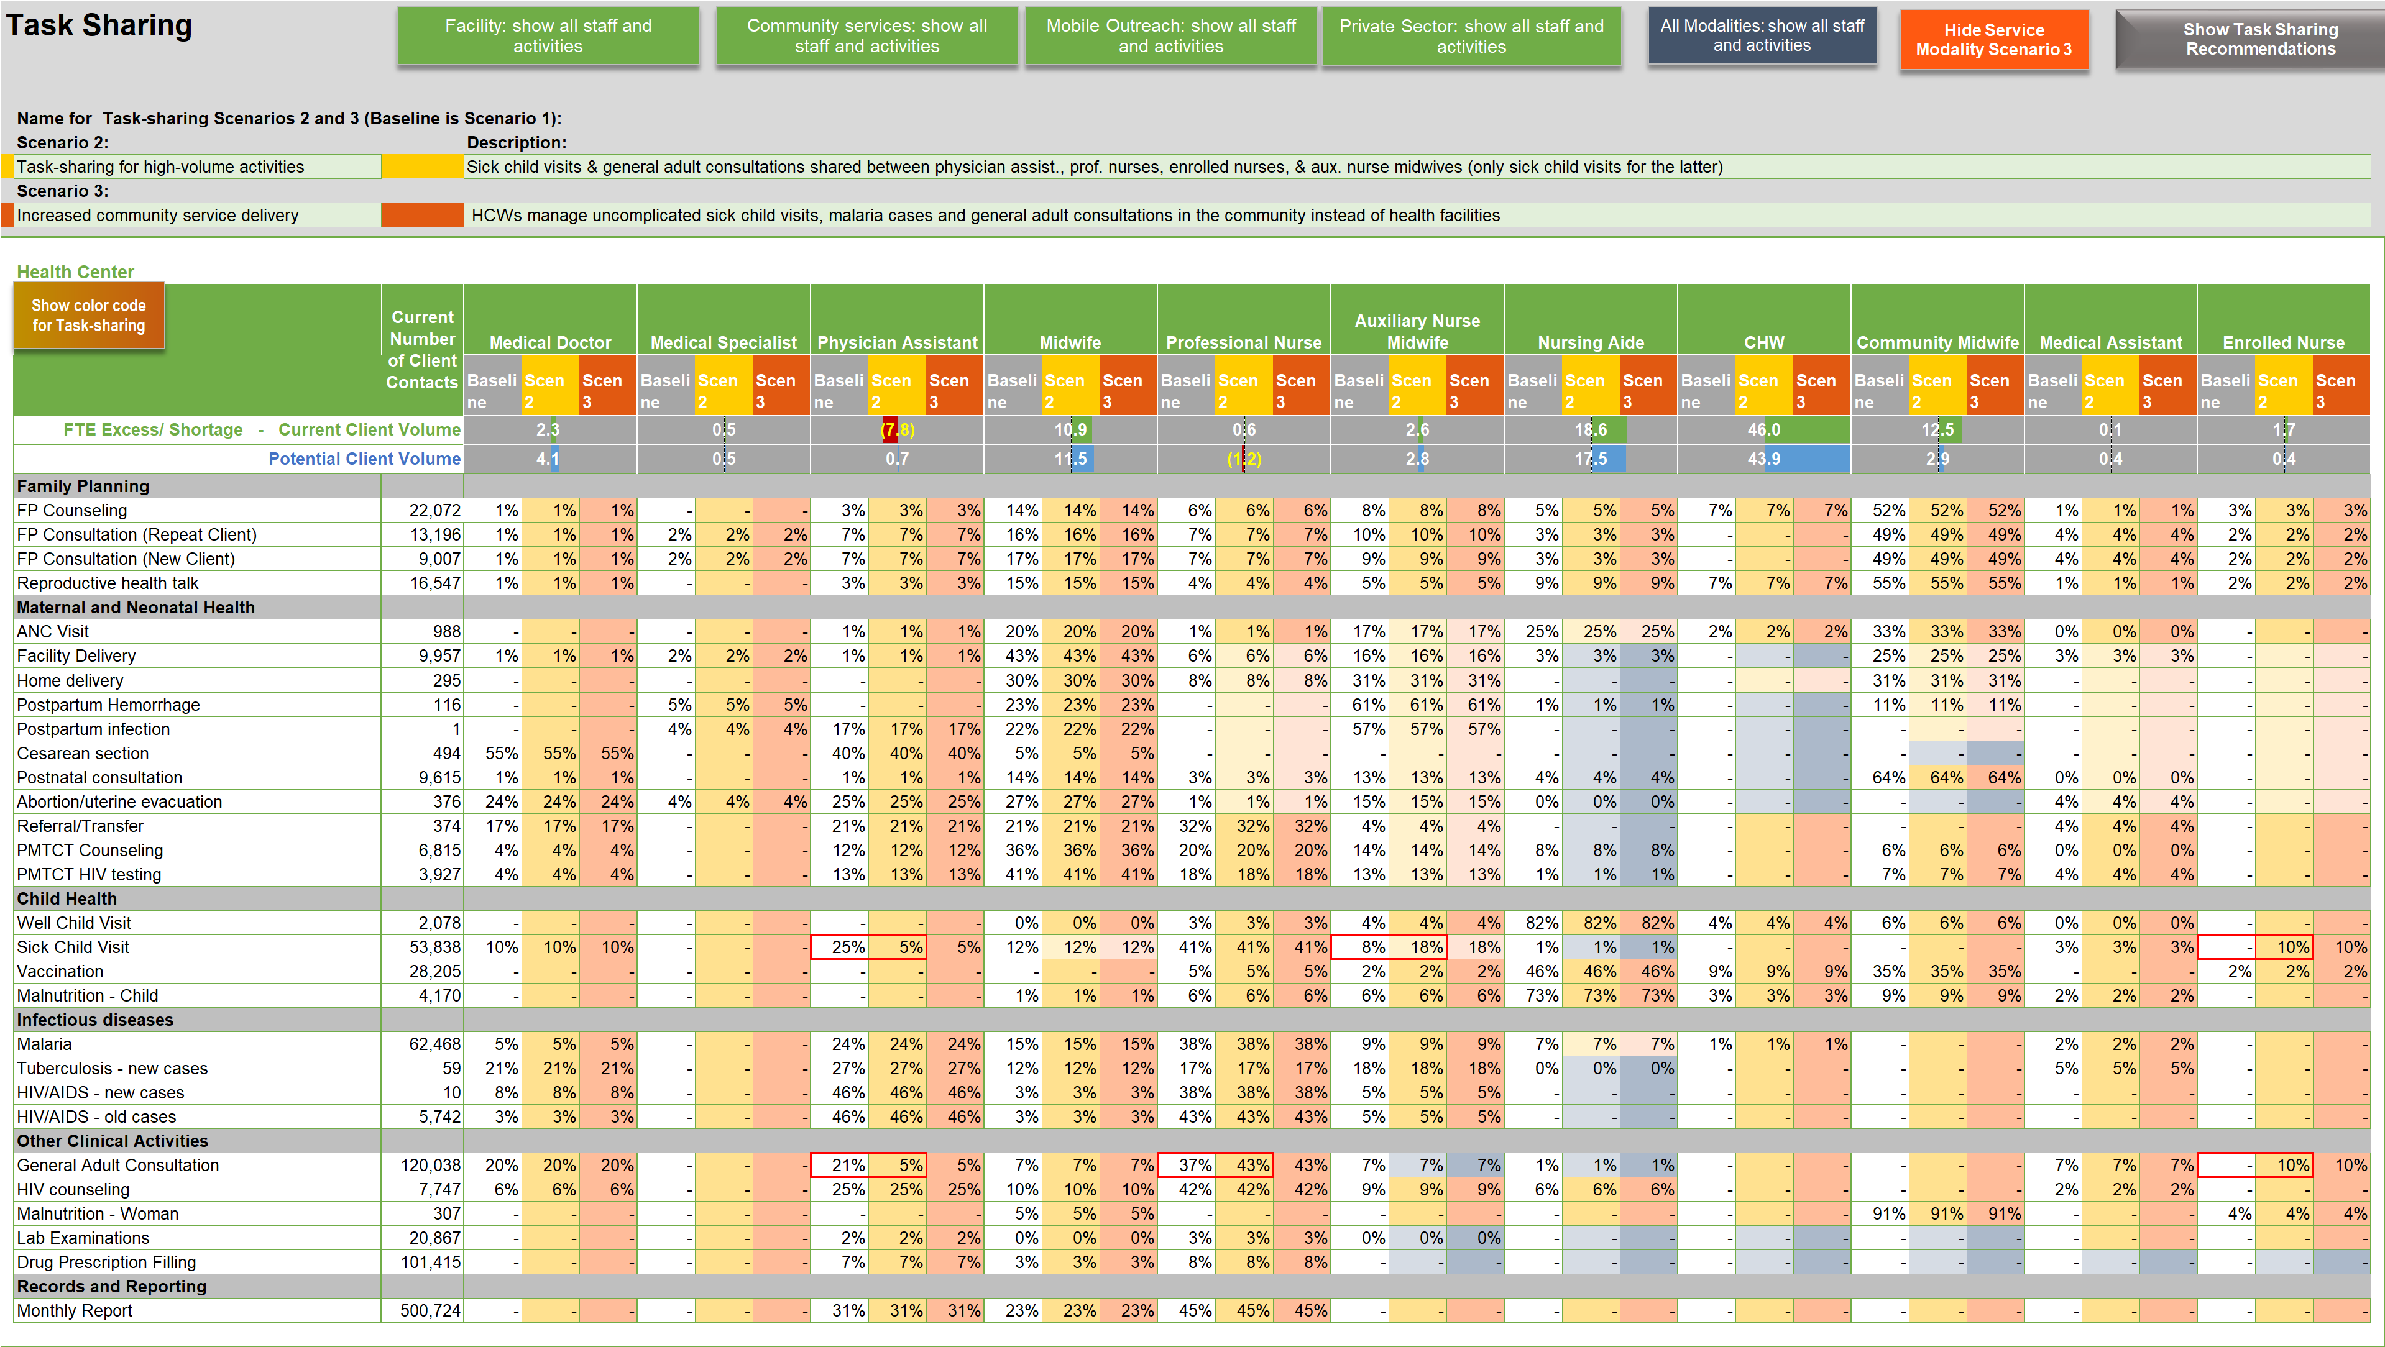

Figure 21. Tab to develop task-sharing scenarios 2 and 3 for services delivered at health facilities



Figure 22. Tab to develop task-sharing scenarios 2 and 3 for services delivered in communities

Users also have the option to display all four service modalities or one modality at a time. Figure 21 shows task-assignments for services delivered at the health facility. Figure 22 shows task-assignments for services delivered in the community. Similar tables are available for mobile outreach and private sector services on hidden tabs according to the user sections on the **Start** tab.

DATA ENTRY

*Rows 5 and 7*: Enter the title, short name, and description for task-sharing scenarios 2 and 3 (if the latter is shown).

*Columns G through CF (CU for mobile outreach)*: Allocate client volume to service provider cadres in percent for task-sharing scenarios 2 and 3 as needed. The initial task assignments from tabs **4.a – d**, baseline task-sharing scenario 1, are shown as a reference but cannot be changed here.

*Note*: when first using HOT4PHC the task assignments for scenarios 2 and 3 are the same as the baseline task assignments. Users can overwrite these formulas.

HRH RESULTS

*Rows 13 and 14*: Show staffing gaps and surpluses as FTEs by cadre for the two scenarios selected by the user on the **DASHBOARD**. Any changes to the task assignments are immediately reflected in FTE shortages or excesses in these rows.

The staffing needs for the three task-sharing scenarios are compared on the **DASHBOARD**.

## 7. COSTS (*optional*)

This tab shows the salary costs for the existing staff and the additional funding required to close any staffing gaps. It also estimates the cost – per diem, lodging and travel – related to the provision of community-based services and for community engagement and systems support activities. Users can provide a budget envelop by funding source for these activities and explore how many more staff can be hired with available funding and what budget gaps remain for per diems, lodging and transportation.

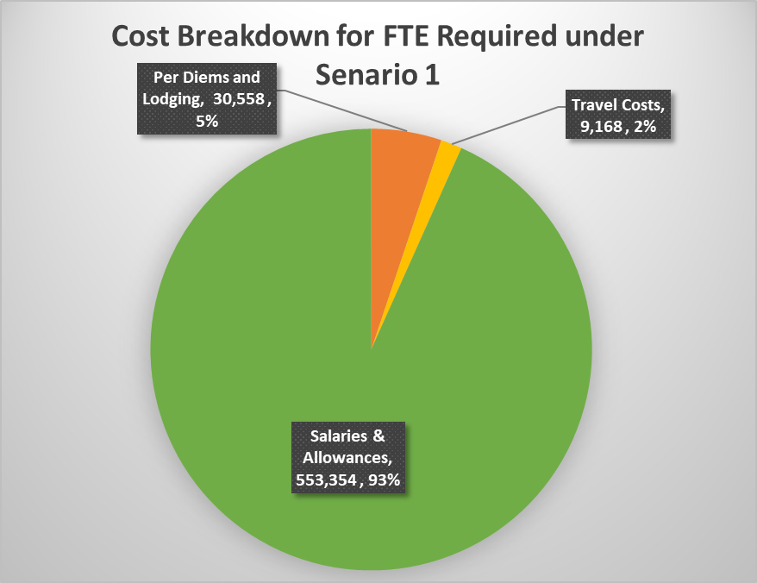

Figure 23. Breakdown of major cost items

ACTIONS

*Radio buttons in P/Q3*: Select whether to show values in local currency or US$. The line below indicates in which currency cost data have been preconfigured on the hidden tab **G**, **Cost Data**. Users can switch freely between currencies.

*Costing Inputs*: Verify transport availability at this facility and adjust where necessary.

*Costing Results in Figure 24*: Costs are provided for the scenarios selected by the used on the **DASHBOARD** by default. The user can select a different second scenario by unchecking the checkbox and selecting from the blue dropdown box.

*Show or hide unused staff*: Click the button to simplify staff tables.

DATA ENTRY

*3. Budget Envelop in Figure 25*: Enter available funding sources in the first table. Enter the funding available in the second table.



Figure 25. Budget envelop and deficit or surplus



Figure 24. Salary costs for 3 scenarios: FTEs available, scenario 1 FTEs required for current client volume, FTEs required for scenario 2

*4. Additional hiring or purchases in Figure 26*: Specify how many additional staff you plan to hire in column H of the first table.

*Additional Procurements*: The first line is reserved for GeneXpert procurements. Enter the number to be procured. Costs are preconfigured. The remaining lines can be used for any additional procurements.

HRH RESULTS

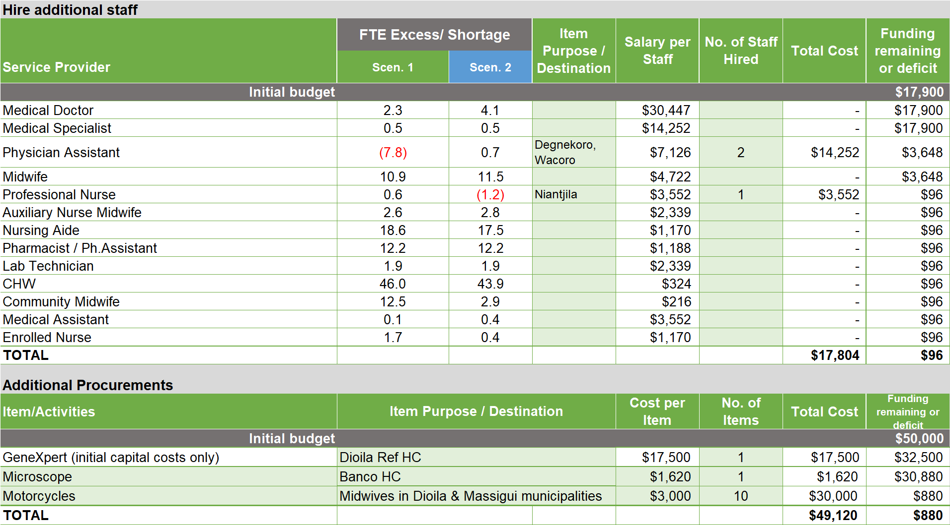

Figure 26. Additional hiring or procurements

*Costing Results*

*1. Total annual personnel costs*: Total annual salary costs and costs to close any staffing gaps are shown in the first table.

*2.* *Per diems and transportation*: The second table shows cost associated with providing services in the communities, community engagement, supervision, continuing education, and drug supply.

*Pie chart*: Breaks down costs into salaries, per diem and lodging, and transportation allowances.

*Bar chart*: Shows costs broken down by community service delivery, community engagement, supervision, continuing education, drug supply, and other community activities.

*3. Budget Envelop*: Shows funding required and deficits or surpluses based on the number provided by the user.

*4. Additional hiring or purchases*: The first table shown how many additional HCWs can be hired with the available budget envelop. The second table shows how much additional equipment and supplies can be purchased with available funding. The bar chart compares funding required and available for equipment and supplies, travel, per diem and lodging, and salaries.

*Bar chart in Figure 27*: Show budget deficits or surpluses by comparing funding required and available.

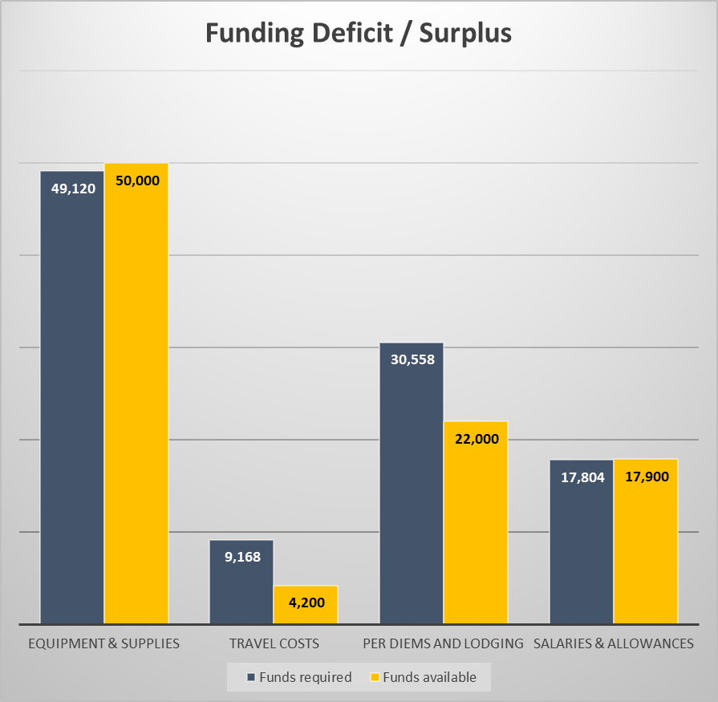

Figure 27. Funding required and available

# HRH Results

The **DASHBOARD** and several **multi-facility summary sheets on purple tabs** provide a detailed analysis of HRH results. If the tool is used for a ***single health facility*** as selected on the **Start** tab, only the **DASHBOARD** shows. If ***multiple facilities*** are imported into HOT4PHC the **DASHBOARD** and **multi-facility summary sheets** show. In this case, the **DASHBOARD** will contain the ***aggregate*** data from multiple facilities as indicated on the **Start** tab. This can be the aggregate from all imported health facilities or for a subset of facilities if a filter is selected on the **FTE Summary** tab.

## DASHBOARD

* *Row 2*: To select two user scenarios for comparing HRH results, the user can use the radio buttons to choose from a shorter list of essential options or from a longer comprehensive list of potential scenarios. Most users will find the essential list easier to navigate. The number of options presented can be further narrowed by specifying whether to only chose from a list of:
* Clinical PHC activities
* Clinical plus community engagement and systems support activities at current coverage levels
* Clinical plus community engagement and systems support activities at 100% coverage levels
* *Row 3*: shows buttons that take the user to different parts for the **DASHBOARD** to avoid excessive scrolling. These buttons are repeated throughout the **DASHBOARD**.

ACTION: select the two scenarios in the green and blue dropdown boxes for comparing HRH results throughout the tool.

The following describes each part of the **DASHBOARD** following the order of button labels.

* *User scenarios and charts:* Green and blue bar charts and tables show the essential HRH results for the two scenarios selected by the user; an example of two user scenarios is shown in Figure 28. Unused row in the tables can be hidden with the press of the button on top of the sheet. In addition, information on the right shows the density of physicians, professional and associate nurses, and midwives per 10,000 population (a measure defined by the WHO). The staffing level shows how far from the ideal of 100% this facility is. The remaining information show the service modality and task-sharing scenarios and their description previously entered on the **2. PHC Delivery** and **6. Task Sharing** tabs.



Figure 28. Examples of two user-selected scenarios for all FTE comparisons throughout the tool

* *Service modality impact on FTEs:* Compares the FTE requirements and shortages or excesses for the three PHC service modality scenarios, as applied by the user on tab **2**, **PHC Delivery**. FTEs are shown for each service modality by cadre for clinical activities (for community engagement and systems support activities there is only one task assignment scenario). Task-sharing levels are the same across all three modality scenarios depending on the user scenario selected as a reference.
* *Service Modality Impact on HIV/ART (optional)*: Compares the FTE requirements and shortages or excesses for the three ART service modality scenarios, as applied by the user on tab **2.a**, **ART Delivery**.
* *Task-sharing Impact on FTEs*: Compares the FTE requirements and shortages or excesses for the three task-sharing scenarios, as applied by the user on tabs **4.a – d TA** and tab **6**, **Task Sharing**. FTEs are shown by cadre for clinical activities where task-sharing can be applied; for community engagement and systems support activities there is only one task assignment scenario. Service modalities are the same across all three task-sharing scenarios depending on the user scenario selected as a reference.
* *FTE Analysis by Program – Charts*: Compare the FTE requirements and shortages or excesses for the four program areas built into HOT4PHC: PHC services, Special Program activities, HIV/ART services, and community engagement and systems support activities. The bar charts compare existing FTEs with required FTEs for these program areas and the total. There are two green charts for the user scenario 1 and two blue charts for user scenario 2 selected earlier on top of the **DASHBOARD**.

These two sets of bar charts reflect the staffing situation before and after changes to staffing and client volume due to a public health emergency such as the COVID-19 pandemic. The user can explore the HRH impact by selecting one option for the impact on staffing and one option for the impact on client volume; the combined effect can be studied as well. The slider options are the quickest way to estimate the impact where the selected levels are applied across all PHC activities (except special programs) and/or all service provider cadres. Users can set the sliders to the values desired. If no impact is selected, the before and after charts are the same.

* *FTE Analysis by Program – Tables*: Compare the FTE requirements and shortages or excesses for the four program areas built into HOT4PHC: PHC services, Special Program activities, HIV/ART services, and community engagement and systems support activities. They show the staffing situation based on the selection of the impact of a public health emergency; only the charts provide a before and after comparison.

HOT4PHC can analyze FTE requirements based on whether staff are providing PHC services in general or are dedicated to Special Programs and/or HIV/ART services. This assignment is done on the hidden tab **C**, **Service Providers**. If no staff is dedicated to a program area, the values for the total and PHC staff are the same and zero on the bottom two rows of the tables.

* *FTEs per Activity Type - Scenario 1*: The left horizontal bar chart shows the proportion of FTEs required for clinical services and for community engagement and systems support activities for user scenario 1. The first pie chart and table break out FTE requirements by clinical activity groups and by community engagement and systems support activity groups for user scenario 1.
* *FTEs per Activity Type - Scenario 2*: The right horizontal bar chart shows the proportion of FTEs required for clinical services and for community engagement and systems support activities for user scenario 2. The second pie chart and table break out FTE requirements by clinical activity groups and by community engagement and systems support activity groups for user scenario 2.
* *Scenario 1 FTE Storyline*: This is an experimental feature for user scenario 1. The first table shows which service providers face the greatest shortage based on the cutoff selected by the user and with which other service provider cadres could a task be shared with at facility and community levels. This is based on staff availability and eligibility as defined on the hidden tab **E**, **Task Sharing Guidelines**.

The second table shows which staff have the greatest excesses based on the cutoff selected by the user and which data verification and adjustment steps users can take to ensure data accuracy. In a second step, users can explore task-sharing and changing the service modalities to reduce staff excesses.

* *Scenario 2 FTE Storyline*: Same as the Scenario 1 FTE Storyline but for user scenario 2.

# APPLYING HOT4PHC AS A MASTER TOOL

To import data from several health facilities, follow these steps.

## Import data from tools completed for individual health facilities

1. Select “New health facility, no aggregation” from the dropdown menu on line 1 to complete HOT4PHC for each health facility by, at minimum, entering the catchment area population and community size on the **START** tab, annual client volume on tab **1**, the number of service providers and weekly hours on tab **3**, and initial task assignments on tabs **4.a** and **b**. Tab **5** for community engagement and systems support activities can be preconfigured and applied to all facilities with minor adaptations. Enter the date on the **START** tab and save each completed tool by using the “Save tool under a new name” button on the **START** tab. Accept the default filename and select a folder on your computer where all completed tools will be saved.
2. Save all completed tools in the same target folder on your computer.
3. Select “All health facilities” to import data from all completed tools in the target folder selected under steps 1 and 2. This will work well for about fewer than 120 facilities. For a much larger number of facilities select any other option 3 through 8 for data import and enter the respective label in lines 3-6 or 11, which will selectively import data from a subset of facilities that meet the criteria entered.
4. Users will be prompted several times and asked to select whether the imported data will replace or be appended to data already in the tool. When appending data, the tool can check for duplicates, which will slow the import; it is recommended only for a few facilities, else a complete reimport will be faster.
5. The import procedure will ignore any non-HOT4PHC files in the target directory.
6. As the last step, HOT4PHC will aggregate the data from all imported facilities and copy these aggregate data into their respective tables on all the red tabs described earlier. Users can use the aggregate data on these tabs to test task-sharing and service diversification and assess their district-wide staffing impact. Such aggregation presents a hypothetical scenario assuming that all health facilities are configured with the same client volume and staff mix. A realistic setup must be created in the tools for individual health facilities because each facility is organized differently. After the individual HOT4PHC files have been revised, data must be reimported into a new master tool.

The following tabs will summarize the staffing situation and efficiencies for all or some of the imported health facilities. The latter is done by filtering the imported data in the **FTE Summary** tab. If data are filtered, the aggregated data will only include facilities selected and their numbers shown on the **START** tab.

## FTE SUMMARY

This and the following HRH results tabs only apply to ***multi-facility data imports***; they are hidden when HOT4PHC is used for a single health facility (although data from multiple facilities may still be in the tool to create tools for single facilities). These tabs use the Excel pivot table features that allow filtering of health facilities by geographic area and other criteria. At first, all data for all health facilities imported will show, organized by region, district, and sub-district (municipality). To filter facilities, select criteria on the left (orange). By default, only one criteria can be applied at a time, for example, one of the municipalities. Optionally, two criteria can be selected by changing the dropdown item in cellA2. The filter selected will apply to this and all the following HRH results tabs. To cancel filters, click the “reset all filters” button. Filtering HRH results is the only user action for these tables; no data must be changed here or on the following tabs.

The **FTE Summary** tab shows the FTEs available and shortage or excess for each available service provider cadre. The number of communities (villages) and population size in the facility catchment area as well as the client volume per facility is shows as a reference. Four of the last five columns show the total FTEs available, the average shortage or excess, and their lower and upper bounds. A good staff balance would show average shortages or excesses close to zero. The last column shows staffing levels in percent; an adequately staffed facility should be close to 100%.

Separate tables are provided for user scenarios 1 and 2.

## FTE CHART

These charts show the same FTE information as the **FTE Summary** but one service provider cadre at a time or all combined for user scenario 1 only. The selection is made from a dropdown box in column B.

## PHC EFFORT

These tables summarize FTEs required by clinical service and community engagement and systems support groups. The estimation of coverage levels for key services is experimental and may not yet accurately reflect actual coverage. Separate tables are provided for user scenarios 1 and 2.

## SPECIAL [PROGRAMS] & ART

These tables show FTE requirements by program area, if applied by the user. Separate tables are provided for user scenarios 1 and 2.

## COMMUNITY+

This table shows the coverage for community engagement, supervision, continuing education, and drug supply activities under current levels of effort. Coverage levels are only calculated for frontline health facilities but not for referral centers. Supervision of community-based workers in health facilities without CHWs will not be applicable (greyed out). Coverage levels may be high if targets for these activities are set low on tab **5**, **Community & Support**.

# HOT4PHC Customization

Tool ***customization*** for a specific country context is done on eight green tabs, **Set Up and A – G**. These sheets are hidden and reserved for the local HOT support team and should not be changed by the tool user. These country-customized settings apply to all health facilities, while the HOT4PHC application by tool users is done for individual health facilities.

## Set Up

This tab sets the user language for the tool from a dropdown menu. This should be done once before the tool rollout. While the language can be changed at any time after the user has entered data, user input cannot be translated, only the language for the tool interface will change.

## A. PHC Activities

This tab customizes the list of clinical PHC activities by using country-specific terminology in columns D through J for any of the preconfigured activities in columns B and C. The best approach is to align country terminology with the preconfigured list, because it is tied to the task times in tab **D**, **Task Times**. Any activities that do not apply would simply not be used. If there are activities not in this list that take up a significant amount of service providers’ time it is best to use the undefined activities “Other [Specify]” by replacing their labels in the light green cells. All Special Program activities can be assigned as needed. Tools for customizing PHC activities can be downloaded and used with service provider expert groups.

Clinical PHC and Special Program activities require additional information:

Average number of visits per year

* Average number of lab tests required per year
* Can this activity be done in a group setting (Y/N)?
* Is an activity done by a team and not by a single HCW? For example, a consultation is usually done by one HCW; health education is often done for a group of clients. For GeneXpert tests, the group refers to the cartridge capacity of the machine.

Exceptions from the above – the following activities are handled differently:

* Lab examinations/tests: If lab tests are handled by dedicated staff such as a lab technician, enter “1” in cell F41; if lab tests are included in consultations enter “0”. In addition, specify a percentage of the client volume requiring lab tests in column O. HOT4PHC uses these to estimate the number of lab tests if they are unknown to the user.
* Drug prescription filling: If drug prescriptions are handled by dedicated staff such as a pharmacists or pharmacist assistants, enter “1” in cell F45; if drug prescriptions are included in consultations enter “0”. In addition, specify a percentage of the client volume requiring drug prescriptions (less vaccinations and preventive services) in column O. HOT4PHC uses these to estimate the number of drug prescriptions if they are unknown to the user.
* Three highlighted activities can be used for GeneXpert tests by copying the highlighted text in column R to cells D42 through D44 as needed.

HIV/ART services and activities are configured differently:

* ART services are first assigned to one or more of the five ART models.
* For each ART activity an annual client contact frequency is specified for one or more ART models of care.

## B. Modalities

This tab applies country terminology to the four service delivery modalities and to the four types of health facilities.

## C. Service Providers

This tab adapts the health workforce to country terminology. The first 13 service provider cadres follow WHO nomenclature; only the country names in column D and their abbreviations in column F will be used by the tool. These can be in any language. User added staff 14 through 25 need to be mapped to one of the first 13 cadres; this will be used to assign task times and to calculate costs. Row 29 is reserved for the GeneXpert diagnostic system. It is shown with staff, because HOT4PHC calculates requirements in the same manner. In addition, the following information is needed:

Whether to include a service provider cadre in the tool or not. Only service providers marked with an “x” will show on sheets 2 through 7.

Indicate with an “x” whether certain staff is dedicated to either Special Programs or ART, but not both. Unmarked staff are assumed to deliver all PHC tasks including Special Programs and ART.

Indicate with an “x” whether the shorter or longer task times for the D. Task Times tab should be applied to a cadre. This is appropriate for more experienced cadres with advanced degrees and staff from referral facilities because they tend to see cases with more serious conditions.

Specify the standard number of workweeks per year for staff.

The bottom part of the table is only applicable is the facility receives or provides mobile outreach services that involve staff from the outside, such as district or NGO service providers. These, too, need to be matched to one of the first 13 service providers.

## D. Task Times

Three task times are required for each clinical activity, the average, minimum and maximum times. All task times are in minutes for one provider-client interaction. Two sets of times can be configured, a set of shorter times most appropriate for frontline facilities and less skilled or experienced staff, and a set of longer times for referral facilities and staff with advanced degrees. These task times are applied to all service provider cadres across all service modalities. However, times for individual tasks and cadres can be adjusted, but this is not recommended as maintaining thousands of data points would be very difficult. Moreover, adjusting task times by a few minutes for one provider has very little impact on FTE requirements.

HOT4PHC come prepopulated with task times based on data collected in Mali. These can be used as a first approximation in other countries, but most likely there will be a desire to review and adjust these data based on country-specific practices. The most convenient source for task times reviews are consultations with small expert provider groups. Tools for validating tasks and task times are available for download. This can be done in a few 2-hour session managed virtually. A much more expensive and time-consuming method would be time-motion studies with direct observations. The additional gains in precision may not warrant the costs.

## E. Task Sharing Guidelines

For each clinical task and community engagement, supervision, continuing education, and drug supply activity a service provider cadre is designated as “recommended”, “recommended as assisting or with supervision only” and “not recommended”. This designation is used to format all tabs with a task-sharing function: tabs **4.a – d**, **5.** and **6.** This will help tool users to assign tasks only to qualified personnel. The designation is done by copying and pasting the appropriate symbols in the table. Tools for customizing PHC activities can be downloaded and used with service provider expert groups to determine the level of task-sharing possible following national and international guidelines.



Figure 29. Options for classifying service provider cadres role in task sharing

## F. DHS Data

This is an experimental tab. Its data are used to establish coverage benchmarks for key PHC activities. It uses country-specific DHS data as well as data published in the literature, which may be based on research from other countries. These tables need to be updates once a new DHS or new research becomes available.

## G. Cost Data

Tables in this tab capture salary and related information such as hardship allowances, bonuses, housing allowances, and stipends for each service provider cadre. In addition, travel-related information for providing community-based services and community engagement and systems support activities need to be entered—per diems, lodging and transportation allowances for each cadre. Data can be entered in local currency or as US$ as selected in cell D2, but it needs to be decided up front and not changed later.

1. University Research Co. (URC), an HRH2030 partner, led the development of HOT4PHC (as well as HOT4FP and HOT4ART). All tools are available on the HRH2030 website: <https://www.hrh2030program.org/>)
2. User guides and other materials for the HOT4ART Tool may be found at <https://hrh2030program.org/tool_hrh-planning-for-hiv/>.